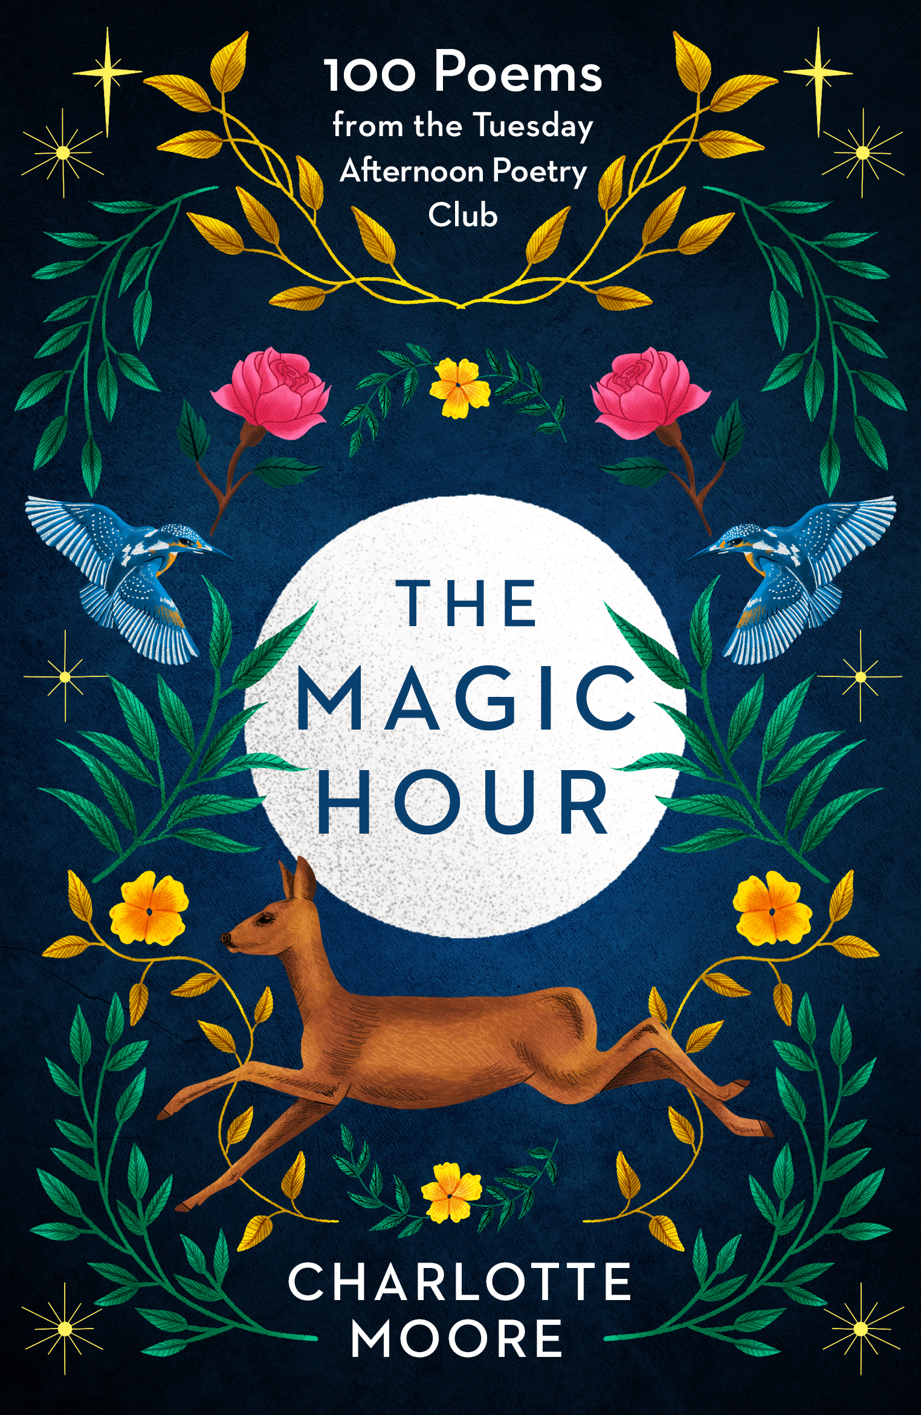
THE
MAGIC HOUR
100 Poems from the
Tuesday Afternoon Poetry Club

CHARLOTTE MOORE

‘I loved this book so much: warm, honest, informed, generous, original…
It is so various and redeemed from so many hidden corners, it would be difficult to think of an anthology more richly packed. Which of course makes it for me the perfect desert island book.’
Adam Nicolson
PUBLISHED BY SHORT BOOKS IN PAPERBACK ON 15 OCTOBER 2020 £12.99
ALSO AVAILABLE AS AN E-BOOK
“Reading a poem gives us a glimpse of past and future possibilities, other worlds and other lives. It makes a gift of unfamiliar words, and refreshes parts of the mind that other art forms cannot reach…”

Charlotte Moore, a writer and former English teacher, has loved poems all her life. Last year, realising how much she missed reading them aloud in class, she decided to set up a weekly poetry club for anyone interested, asking poetry addicts and complete beginners alike to join her at her kitchen table. This book brings together a selection of the Tuesday afternoon poetry club’s favourite poems, some well-known, some less so. The poems are grouped into themes – from home and lovers, to war and the planets – each framed with a little context from Charlotte and delightful insights from members of the group.

The Magic Hour offers a source of lifelong pleasure and nourishment, with words to delight and console, while reminding us of moments of personal significance. It demonstrates how we can all benefit from adding a small dose of poetry into our daily lives.

‘A beautiful collection, full of wonderful surprises and old favourites’
Clover Stroud

‘The Magic Hour has the powerful charm and the heart-lifting sense of surprise and discovery of the best poetry and the best anthologies. I shall keep it near my favourite chair and give it to many.’
Hattie Ellis

Charlotte Moore read English at Oxford before becoming a teacher for twelve years. She is now a freelance author and has written three novels as well as a long-running column for the Guardian, and a highly acclaimed family history, Hancox (Viking, 2010/Penguin, 2011). She lives in Battle, Sussex.

Follow the Poetry Afternoon Club on Instagram @Magic_Hour_Poems

