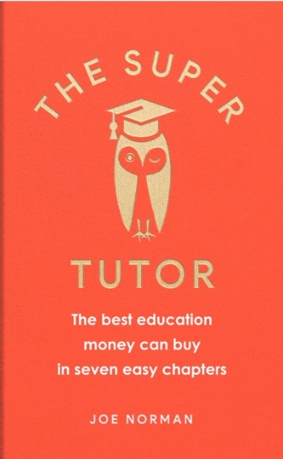
THE SUPER TUTOR
The best education money can buy in seven easy chapters
Joe Norman

To be published by Short Books in Hardback
on 4th April 2019, £12.99

‘William Morris said that one should
Have nothing in your home that you neither know to be useful, nor believe to be beautiful.
I believe the same thing is true of our minds. Education doesn’t ultimately happen in schools or universities or in the many forms of adult education available, or in public libraries, or even – saints preserve us! – online. Your education happens exclusively in your head, and that will always be true. Who’s driving this car? You are.
The contents of this book are largely things I was taught 20-25 years ago, which are still available to me now, because they stayed with me. Most of the quotations are made from memory. That’s the only real criterion for inclusion. Do I still remember it decades later?
I hope this book will reach not just avid young scholars, but also those who are not in formal education any more (of course, your informal education continues throughout your life; perhaps, if you’re like me, without you even noticing). What’s on offer here is the best academic education available in the English-speaking world, one focused on the intrinsic value of knowing interesting stuff, all sifted through the gaping holes of the colander I like to call my mind.’ Joe Norman

For Joe Norman, education is what you still remember when you have forgotten everything else. What ideas have stayed with you from the classroom? How do you write an essay? How do you read a poem?

Whether you are still a student or long finished with formal education, The Super Tutor offers a first-class schooling for anyone who wants to learn – the kind of learning that will stay with you a lifetime. Drawing on fifteen years of tutoring, Joe Norman shares with his readers his top seven essential and imaginative lessons, including: how to write, how to read, common mistakes and, most importantly, how to think. Stripping away grades, praise, university places or examiners, this book celebrates the love of learning things for their own sake.

The Super Tutor’s core lessons:
How to Read Comprehension
How to Write How to read a Poem
How to Write an Essay How to Tutor
Common Mistakes: Apostrophes to Accusatives

Whether you are still a student (11+ and upwards) or long finished with formal education, The Super Tutor offers a first-class schooling for anyone who wants to learn, and how to master the kind of learning and education that will stay with you a lifetime.

About the author:
Joe Norman has been a tutor of children aged 10-13 for nineteen years. He specialises in training children for entrance and scholarships to top schools such as Eton, Winchester and Westminster. He studied at Winchester College and Oxford University.

Joe Norman is available for interview and to write articles
Extracts are available

All publicity enquiries and review copy requests to:

Katherine Stroud - email kstroudpr@gmail.co.uk - tel 07780 112964
Becke Parker - email becke@bparkerpr.co.uk - tel 07810 480924

