PRESS RELEASE

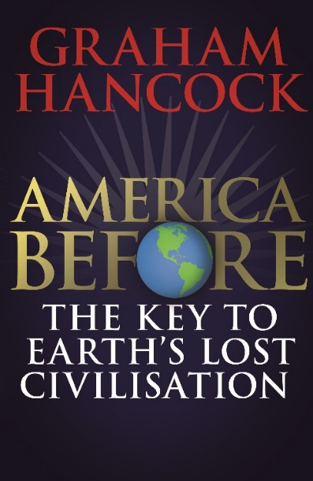
AMERICA BEFORE
THE KEY TO EARTH’S LOST CIVILISATION
Graham Hancock

To be published 2nd April 2019
£25 hardback

Was an advanced civilization lost to history in the global cataclysm that ended the last Ice Age?

Graham Hancock’s long-awaited culmination of his non-fiction work will be published in Spring 2019 - over twenty years after the publication of the multi-million selling Fingerprints of the Gods and four years after the Sunday Times bestseller Magicians of the Gods. In AMERICA BEFORE: The Key to Earth’s Lost Civilisation, Hancock draws on the latest archaeological and DNA evidence to bring his quest to a stunning conclusion. He presents a brand-new investigation into the prehistory of the Americas, referencing scientific proof of a long-lost ancient civilization which began in the Ice Age in the (misnamed) ‘New World’ and then spread around the earth, leaving its traces in ancient monuments such as the Egyptian pyramids and Stonehenge and in the genetic makeup of peoples living as far away as Australia.

Hancock's research takes readers on a series of journeys and encounters with the scientists responsible for the recent extraordinary breakthroughs. In the process, from the Mississippi Valley to the Amazon rainforest, he reveals that ancient ‘New World' cultures share a legacy of advanced scientific knowledge and sophisticated spiritual beliefs with supposedly unconnected 'Old World' cultures. Hancock follows the clues to their source in the devastated heartland of the lost civilization.

Have archaeologists focused for too long only on the 'Old World' in their search for the origins of civilization while failing to consider the revolutionary possibility that those origins might in fact be found in the 'New World'?

AMERICA BEFORE: The Key to Earth's Lost Civilization rewrites American history as we know it and is the conclusion of decades of work. Within it, Hancock presents a revolutionary exploration of the mystery of ancient civilizations alongside astonishing archaeological discoveries that have profound implications for how we lead our lives today.

About the author
As East Africa correspondent of The Economist in the early eighties Graham Hancock began to write a series of highly acclaimed books on economics, politics and foreign aid. His life took a whole new turn when he became fascinated by rumours that the Ark of the Covenant is a real artefact, hidden somewhere in northern Africa. The story of his detective work, tracking it down to its supposed final resting place became the international bestseller The Sign and the Seal. More bestsellers in the field of 'alternative history' followed, including Fingerprints of the Gods, Keeper of Genesis (the latter co-authored with Robert Bauval) and Heaven's Mirror. In Supernatural he described his experiences journeying to experiment with hallucinogenic drugs amongst tribespeople for whom they represent a gateway into supernatural realms. His ideas on exploring new dimensions in consciousness became the subject of his controversial TED talks. Graham Hancock's books have been translated into twenty-seven languages and have sold over nine million copies worldwide. His public lectures and broadcasts include two major TV series for Channel 4, Quest for the Lost Civilisation, and Flooded Kingdoms of the Ice Age.

Graham Hancock is available for interview and to write articles
Images are available

All UK publicity enquiries and review copy requests to Becke Parker:
email becke@bparkerpr.co.uk / tel 07810 480924

