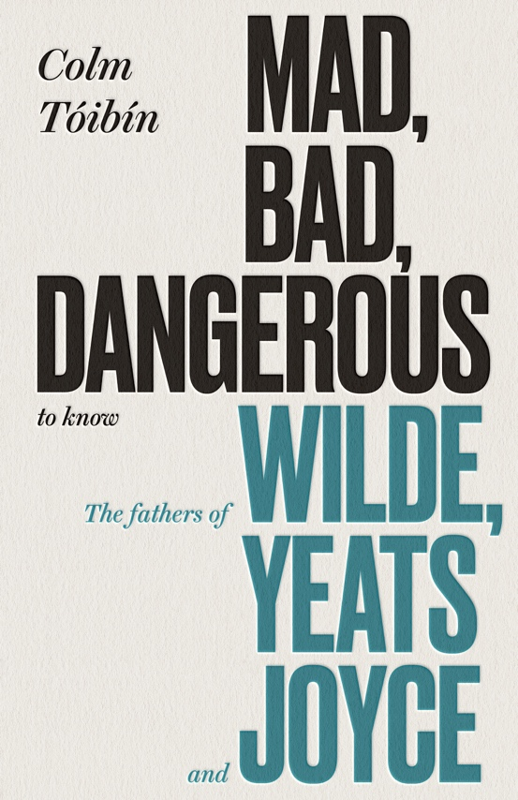
MAD, BAD, DANGEROUS
TO KNOW
THE FATHERS OF
WILDE, YEATS
and JOYCE
COLM TÓIBĺN

‘Toibin is a supple, subtle thinker, alive to hints and undertones, wary of absolute truths’
New Statesman
PUBLISHED IN VIKING HARDBACK ON 25TH OCTOBER 2018, £14.99
Also published by Penguin as an Audiobook read by Colm Tóibín
'A father...is a necessary evil.' Stephen Dedalus in Ulysses
In Mad, Bad, Dangerous to Know, Colm Tóibín turns his incisive gaze to three of Ireland's greatest writers, Oscar Wilde, W.B. Yeats and James Joyce, and their earliest influences: their fathers. From Wilde's doctor father, a brilliant statistician and amateur archaeologist, who was taken to court by an obsessed lover in a strange premonition of what would happen to his son; to Yeats' father, an impoverished artist and brilliant letter-writer who could never finish a painting; to John Stanislus Joyce, a singer, drinker and story-teller, a man unwilling to provide for his large family, whom his son James memorialised in his work.
Colm Tóibín illuminates not only the complex relationships between three of the greatest writers in the English language and their fathers, but also illustrates the surprising ways they surface in their work.
“If there is a more brilliant writer than Tóibín working today,
I don’t know who that would be.”
Karen Joy Fowler
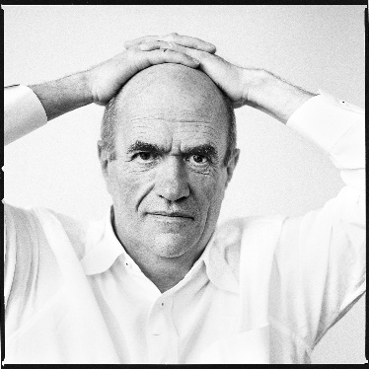
Colm Tóibín was born in Enniscorthy in 1955. He is the author of nine novels including The Blackwater Lightship, The Master, The Testament of Mary and Nora Webster. His most recent novel is House of Names. He has been nominated for the Booker Prize three times, with The Master also winning the IMPAC Award. Brooklyn won the Costa Novel of the Year Award and the film adaptation was nominated for best picture Oscar in 2016 and won Outstanding British film at the Baftas. He has also published two collections of short stories and many works of non-fiction. He is a contributing editor at the London Review of Books and Irene and Sidney B. Silverman Professor of Humanities at Columbia University. He is a member of the Royal Society of Literature, the American Academy of Arts and Letters and the American Academy of Arts and Sciences. He is Chancellor of Liverpool University. His work has been translated in more than thirty languages. He lives in Dublin.

Praise for House of Names;

“Part of Toibin's success comes down to the power of his writing: an almost unfaultable combination of artful restraint and wonderfully observed detail.”
Mary Beard, New York Times

“Brilliant retelling of a Greek Tragedy... This is a novel that is a celebration of what novels can do. “
Alex Preston, Observer

“The book has a controlled hushed quality, like that of a Morandi still life, which only serves to heighten the terror and pity of the tale.”
John Banville
FOR MORE INFORMATION PLEASE CONTACT KATHERINE STROUD
kstroudpr@gmail.com / 07780112964/ www.prcollective.co.uk

