They were supposed to go out with a whimper...
They chose to go out with a BANG N

THE BOOK AMERICA CAN’T STOP TALKING ABOUT
- A New York Times bestseller
- Selected for actress Emma Watson’s book club
- The No. 1 choice for Reading Groups as voted for by US booksellers
- The No. 1 favourite non-fiction book of US librarians in 2017
- Winner of the GoodReads Choice Award for Best History/Biography 2017
- Written by a British author who discovered the story through directing a play
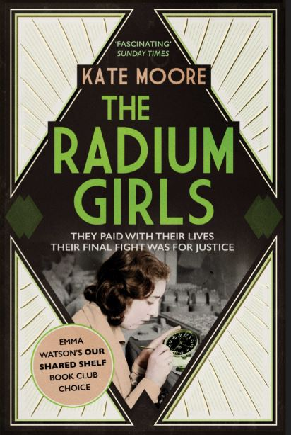
The Radium Girls
by Kate Moore
Published by Simon & Schuster
12th July ǀ Paperback ǀ £8.99

‘Thrilling ’ ‘Exceptional ’ ‘Fascinating’
Mail on Sunday San Francisco Book Review Sunday Times

‘A perfect blend of the historical, the scientific and the personal’ Bustle

The Radium Girls is the incredible true story of the young women exposed to the ‘wonder’ substance of radium and their brave struggle for justice – now in paperback.
During the First World War, teenage girls flocked to work in the new radium-dial studios. As the years passed, the women began to suffer from mysterious and crippling illnesses, but their employers denied all responsibility. So these courageous women – in the face of unimaginable suffering – became determined to fight back, launching a ground-breaking battle for workers’ rights and scientific recognition that still resonates today. Drawing on previously unpublished diaries, letters and interviews, the book showcases the spirit and tenacity of a group of women who refused to stay silent, and in so doing changed the world. By turns heart-breaking, enraging and inspiring, it is an unputdownable and intimate narrative you will never forget.

www.kate-moore.com · www.theradiumgirls.com

