Already a no.1 bestseller in Ireland

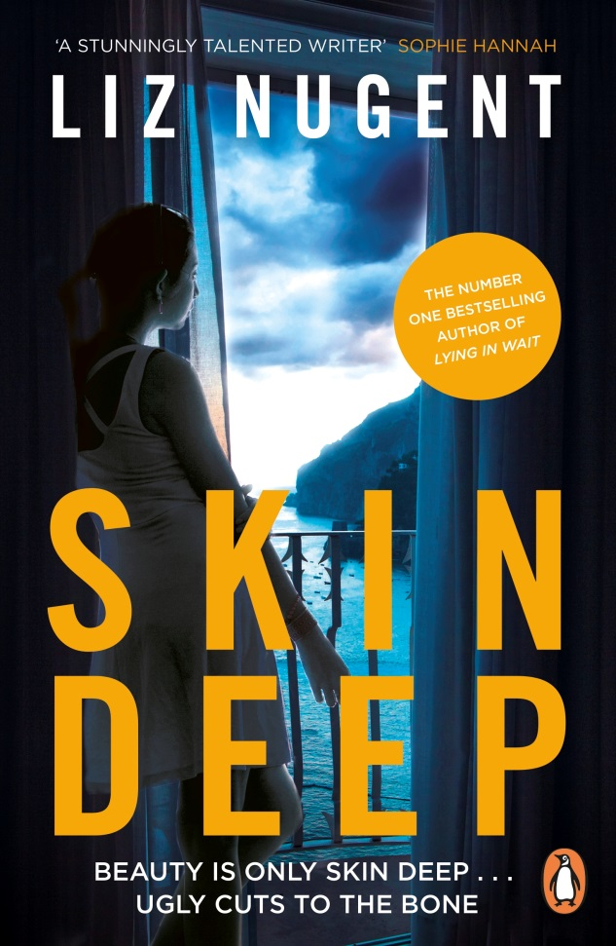
Published by Penguin
15th November 2018 | Paperback | £7.99

SKIN DEEP
by Liz Nugent

‘A stunningly talented writer’
Sophie Hannah

‘I loved, loved, loved Skin Deep - the compassion of it, the beauty of the language, how glamour and horror intersect, how the tension twists tighter and tighter and is brilliantly done’
Marian Keyes

‘Monumentally good. Liz Nugent is a beautiful writer and among the very best storytellers in the world’
Donal Ryan

The deliciously sinister new novel from the bestselling author of Unravelling Oliver and Lying in Wait.
Cordelia Russell has been living on the French Riviera for twenty-five years, passing herself off as an English socialite. But her luck, and the kindness of strangers, have run out.
The arrival of a visitor from her distant past shocks Cordelia. She reacts violently to the intrusion and flees her flat to spend a drunken night at a glittering party. As dawn breaks she stumbles home through the back streets. Even before she opens her door she can hear the flies buzzing. She did not expect the corpse inside to start decomposing quite so quickly . . .
Liz Nugent's novel is the dark, twisted and shocking story of what takes Cordelia from an island childhood in Ireland to ruin in Nice.
Before becoming a full-time writer, Liz Nugent worked in Irish film, theatre and television. In 2014 her first novel, Unravelling Oliver, was a Number One bestseller and won the Crime Fiction Prize in the 2014 Irish Book Awards. Her second novel, Lying in Wait, went straight to Number One in the Irish bestseller charts, remained there for nearly two months and won her a second IBA. She lives in Dublin with her husband.

For further information, to interview or commission a piece by Liz Nugent, please contact: Becke Parker/ becke@bparkerpr.co.uk / 07810 480924

