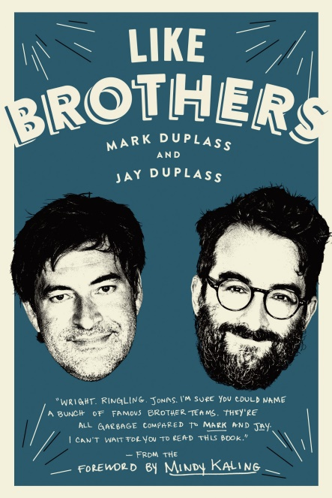
LIKE BROTHERS
MARK DUPLASS
and JAY DUPLASS

Foreword by Mindy Kaling
UK release 24th May
£22.50 hardback / £11.99 ebook

Multitalented writers, directors, producers, and actors Jay and Mark Duplass share the secrets of their lifelong partnership in this unique memoir about the joys and frustrations of intimate collaboration
Whether producing, writing, directing, or acting, the Duplass Brothers have made their mark in the world of independent film and television on the strength of their quirky and empathetic approach to storytelling. Now, for the first time, Mark and Jay take readers on a tour of their lifelong personal and professional partnership in LIKE BROTHERS (Ballantine Books, an imprint of Penguin Random House), a unique memoir told in essays that share the secrets of their success, the joys and frustrations of intimate collaboration, and the lessons they’ve learned the hard way.
Part coming-of-age memoir, part underdog story, and part insider account of succeeding in Hollywood on their own terms, LIKE BROTHERS is also a surprisingly practical road map to a rewarding creative partnership. From a childhood spent wielding an oversized home video camera in the suburbs of New Orleans to their shared years at the University of Texas in early ‘90s Austin, and from the breakthrough short they made on a $3 budget to the night their feature film Baghead became the centre of a Sundance bidding war, Mark and Jay tell the story of a bond that’s resilient, affectionate, mutually empowering, and only mildly dysfunctional. They are brutally honest about how their closeness sabotaged their youthful romantic relationships, about the jealousy each felt when the other stole the spotlight as an actor (Mark in The League, Jay in Transparent), and about the challenges they faced on the set of their beloved HBO series, Togetherness—namely, too much togetherness.
From their obsession with people-watching at airports, to their always-evolving ‘top 10 films of all-time’ list, to their personal email conversations, to their defence of Air Supply, LIKE BROTHERS is as openhearted and lovably offbeat as Mark and Jay themselves.

Mark and Jay Duplass are available for interview
All UK publicity enquiries and review copy requests to Becke Parker:
email becke@bparkerpr.co.uk / tel 07810 480924

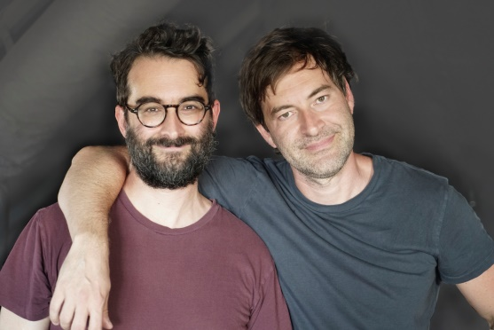
Mark Duplass and Jay Duplass are the critically acclaimed filmmakers behind The Puffy Chair, Baghead, The Do-Deca-Pentathlon, Cyrus, and Jeff, Who Lives at Home. For HBO, they wrote and directed Togetherness, produced the animated series Animals, and created the anthology series Room 104. Their producer credits also include the feature films Safety Not Guaranteed, The Skeleton Twins, and Tangerine. As an actor, Mark has appeared on the hit comedy The League and in such films as Your Sister's Sister, The One I Love, and Blue Jay, while Jay has a leading role on the Golden Globe-winning series Transparent and has appeared in such films as Landline, Beatriz at Dinner, and Outside In. Both brothers had recurring roles on The Mindy Project.

Advance praise for LIKE BROTHERS

“Wright. Ringling. Jonas. I’m sure you could name a bunch of famous brother teams. They’re all garbage compared to Mark and Jay. I can’t wait for you to read this book.”—From the Foreword by Mindy Kaling

“Hilarious...The Duplass Brothers’ entertaining and energetic memoir gives their fans a clear look at the creative genius that drives them.”—Publishers Weekly

“A thoroughly enjoyable peek into the brothers’ creative process, filled with tips and guidance for those who want to follow in their footsteps.”—Booklist

"As creative partners, we sure learned a thing or two from Mark and Jay Duplass's journey through the Hollywood machine. Like Brothers is an essential guide for making space for yourself in a world that doesn't always encourage individuality and innovation. As useful to an aspiring filmmaker as it is to a pair of siblings wondering ‘How do we turn our connection into something great?’ this book will be essential on your shelf."
—Lena Dunham & Jenni Konner

"The Duplass Brothers have a genius for conveying deep feeling without ever straying into sentimentality. Here, they capture the often wonderful and occasionally terrible business of collaborating professionally with someone you love." —John Green and Hank Green

“As a writing team and directing team, we love seeing two people who are more intelligent and articulate than us explore the dynamic that we don’t have the depth or self-reflectiveness to explore ourselves.”
—Seth Rogen and Evan Goldberg

“In my next life, I’d like to come back as a Duplass Brother. But until then, I’ll just enjoy their hilarious, insightful book."—Judd Apatow

Mark and Jay Duplass are available for interview
All UK publicity enquiries and review copy requests to Becke Parker:
email becke@bparkerpr.co.uk / tel 07810 480924

