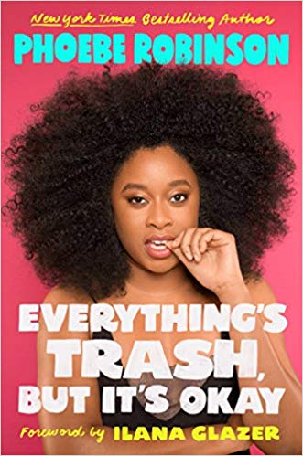
Everything’s Trash
But It’s Okay

Phoebe Robinson

Plume
UK release 18th October
£19.99 hardback & £10.99 ebook

2 Dope Queens star Phoebe Robinson is ready to share everything she's experienced in the hope that, if you can laugh at her topsy-turvy life, you can laugh at your own. Written in her trademark unfiltered, witty style, Robinson's latest essay collection is a call to arms. She tackles a wide range of topics, such as intersectional feminism, beauty standards, and toxic masculinity. A candid perspective for a generation that has had the rug pulled out from under it too many times to count.
A note from Phoebe:
Hey boo boos,
I’m so excited to tell you about my new book, Everything’s Trash, But It’s Okay. If you’ve been feeling like lately the world is a bit of a Dumpster Fire, good news! You’re not alone. I consider myself a trash expert, not only because I see it every day, but because I’ve seen about one hundred thousand hours of reality TV and zero hours of Schindler's List. In my last book, You Can’t Touch My Hair*, I talked through heavy topics like race, gender, and which members of U2 I would most like to sleep with. In my new book, I get deeper: talking about debt, sex, dating in New York, why we need intersectional feminism right now, and why Michael B. Jordan [INSERT JOKE HERE]. I can’t wait for you to read it when it hits shelves this October.

#YQY #LoveYouMeanIt
xo,
Phoebe *New York Times bestseller
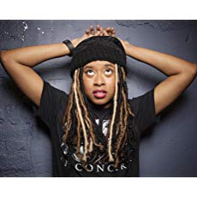
Phoebe Robinson is a stand-up comedian, writer, and actress who has been recognised by Bust, Vulture.com, Essence, O, The Oprah Magazine, and Buzzfeed.com as a rising star, as well as the author of the New York Times bestseller, You Can't Touch My Hair. Most recently, she and Jessica Williams turned their hit WNYC Studios podcast, 2 Dope Queens, into four one-hour HBO specials. Robinson has also appeared on the Late Show with Stephen Colbert, Late Night with Seth Meyers, Conan, Broad City, Search Party, The Daily Show, and the Today show; she was also a staff writer on the final season of Portlandia. When not working in TV, she's the host of the critically acclaimed WNYC Studios interview podcast Sooo Many White Guys. She made her feature film debut in the Netflix comedy Ibiza, released earlier this year.

"Phoebe Robinson brings her infectious charm and utterly delightful sense of humor to her second essay collection, Everything's Trash, But It's Okay. From body image to contemporary feminism to our culture of overwork, Robinson offers deft cultural criticism and hilarious personal anecdotes that will make readers laugh, cringe, and cry. Everything may indeed be trash but writing like this reminds us that we're gonna make it through all the terrible things with honesty, laughter, and faith." - Roxane Gay, New York Times bestselling author
"Just when it feels like the world is falling irreparably apart, Phoebe Robinson is here to make things better. Whether she is unpacking the state of feminism or taking you through the dystopian world of online dating, she is manages to be on point, original, and laugh out loud funny. This vital, unflinching essay collection simultaneously calls out all the bullshit, especially facing women, while making you feel like things are *actually* okay. Even brighter than before, thanks to this hilarious bighearted book." - Gabrielle Union, New York Times bestselling author of We're Going to Need More Wine
"Delightfully recreates the experience of listening to Phoebe dish in person with the added bonus of getting see how words like 'relaysh' are spelled!" - Chris Hayes, New York Times bestselling author of A Colony in a Nation
"This collection is full of whip-smart commentary and extremely relatable trashiness. Phoebe has her own style, her own voice, and practically her own language that gets me every time. She has a way of making us all feel less alone and more bold. I dare you not to laugh your way through this book." -Abbi Jacobson, author of I Might Regret This
"Phoebe is brutally honest and hilarious. I proudly blurb this book without hesitation or remuneration!" -Judd Apatow

Phoebe Robinson is available for interview

All UK publicity enquiries and review copy requests to Becke Parker:
email becke@bparkerpr.co.uk / tel 07810 480924

