MAYIM BIALIK, ACTRESS, WRITER AND NEUROSCIENTIST, EXPLAINS THE SCIENCE OF BEING A BOY IN SEQUEL TO HER NUMBER ONE NEW YORK TIMES BESTSELLER GIRLING UP

BOYING UP
HOW TO BE BRAVE, BOLD AND BRILLIANT
by Mayim Bialik, PhD

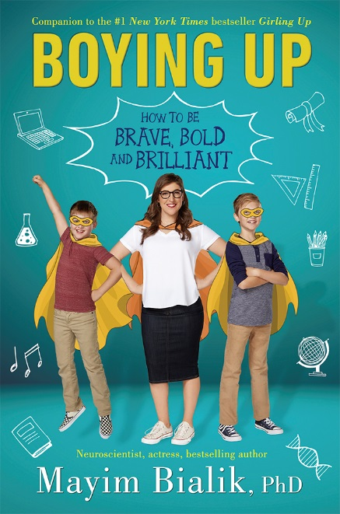
Mayim Bialik, star of The Big Bang Theory and author of the number one New York Times bestseller Girling Up: How to be Strong, Smart and Spectacular, is turning her attention to teen boys in a new book about the science, pressures, and pitfalls of growing up male in today's world. In BOYING UP: How to be Brave, Bold and Brilliant Mayim Bialik uses scientific information from her life as a neuroscientist along with personal anecdotes as a mother of two boys to explain what it means to grow from a boy to a man biologically, psychologically, and sociologically.

In Boying Up, Mayim uses the same down-to-earth, friendly tone that she took in Girling Up to answer questions about the physical and emotional changes associated with male adolescence as well as how to navigate the social and societal pressures that confront tween and teen boys. The book is divided into six sections (How Boys Bodies Work; How Boys Grow; How Boys Learn; How Boys Cope; How Boys Love; and How Boys Make a Difference). Each section includes the voices of real grown up boys from a variety of backgrounds, professions and lifestyles, who contribute with “That’s What He Said…” boxes.

“I am overwhelmed and thrilled with the love Girling Up has received,” says Mayim Bialik. “And I am honored and excited to bring Boying Up into the conversation about how we can best empower young people to be all that they can be. My 9 and 12 year old sons have given me their enthusiastic blessing that I should be confident to joyfully share my scientific wisdom about boys' biological processes, psychological development and behavioral experience in our culture. It's been a wonderful challenge and I cannot wait to share it with everyone!”
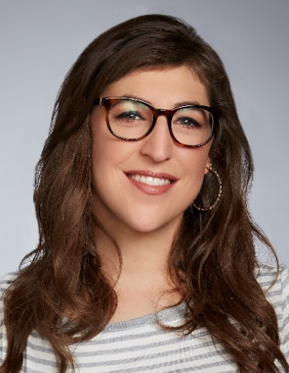
Mayim Bialik is best known as Amy Farrah Fowler on America's top comedy, The Big Bang Theory, a role for which she has received four Emmy nominations and a Critics' Choice Award. She also starred in the early-1990s sitcom Blossom. Mayim earned a BS from UCLA in Neuroscience and Hebrew and Jewish studies, and went on to earn a Ph.D. from UCLA in Neuroscience. She is the author of the New York Times bestseller, Girling Up, as well as Beyond the Sling, and Mayim's Vegan Table.

Mayim founded GrokNation.com in 2015 as a platform for sharing her writing on everything from religious observance and modesty to women's issues to parenting to ​politics. She seeks to present herself as a normal, imperfect mom trying to make everything run smoothly in a world that often feels out of her control. Mayim lives in Los Angeles with her brave, bold and brilliant sons. You can visit Mayim Bialik at groknation.com, follow her on Twitter and Instagram @MissMayim, and watch her videos at youtube.com/mayimbialik.

BOYING UP How to be Brave, Bold and Brilliant
Philomel Books, an imprint of Penguin Random House

UK publication 31st May

£13.33 hardback / £8.99 ebook

Mayim Bialik is available for interview

All UK publicity enquiries and review copy requests to Becke Parker:
email becke@bparkerpr.co.uk / tel 07810 480924

