The Inflamed Mind

STRICTLY
EMBARGOED
UNTIL 3RD MAY 2018
A radical new approach to depression

By EDWARD BULLMORE

Short Books | 3rd May 2018 | Hardback| £14.99 | 978-1-78072-350-1

“Scientists are taking a radical new approach to mental illness – that depression can be triggered by an over-active immune system.”
Fergus Walsh, BBC News

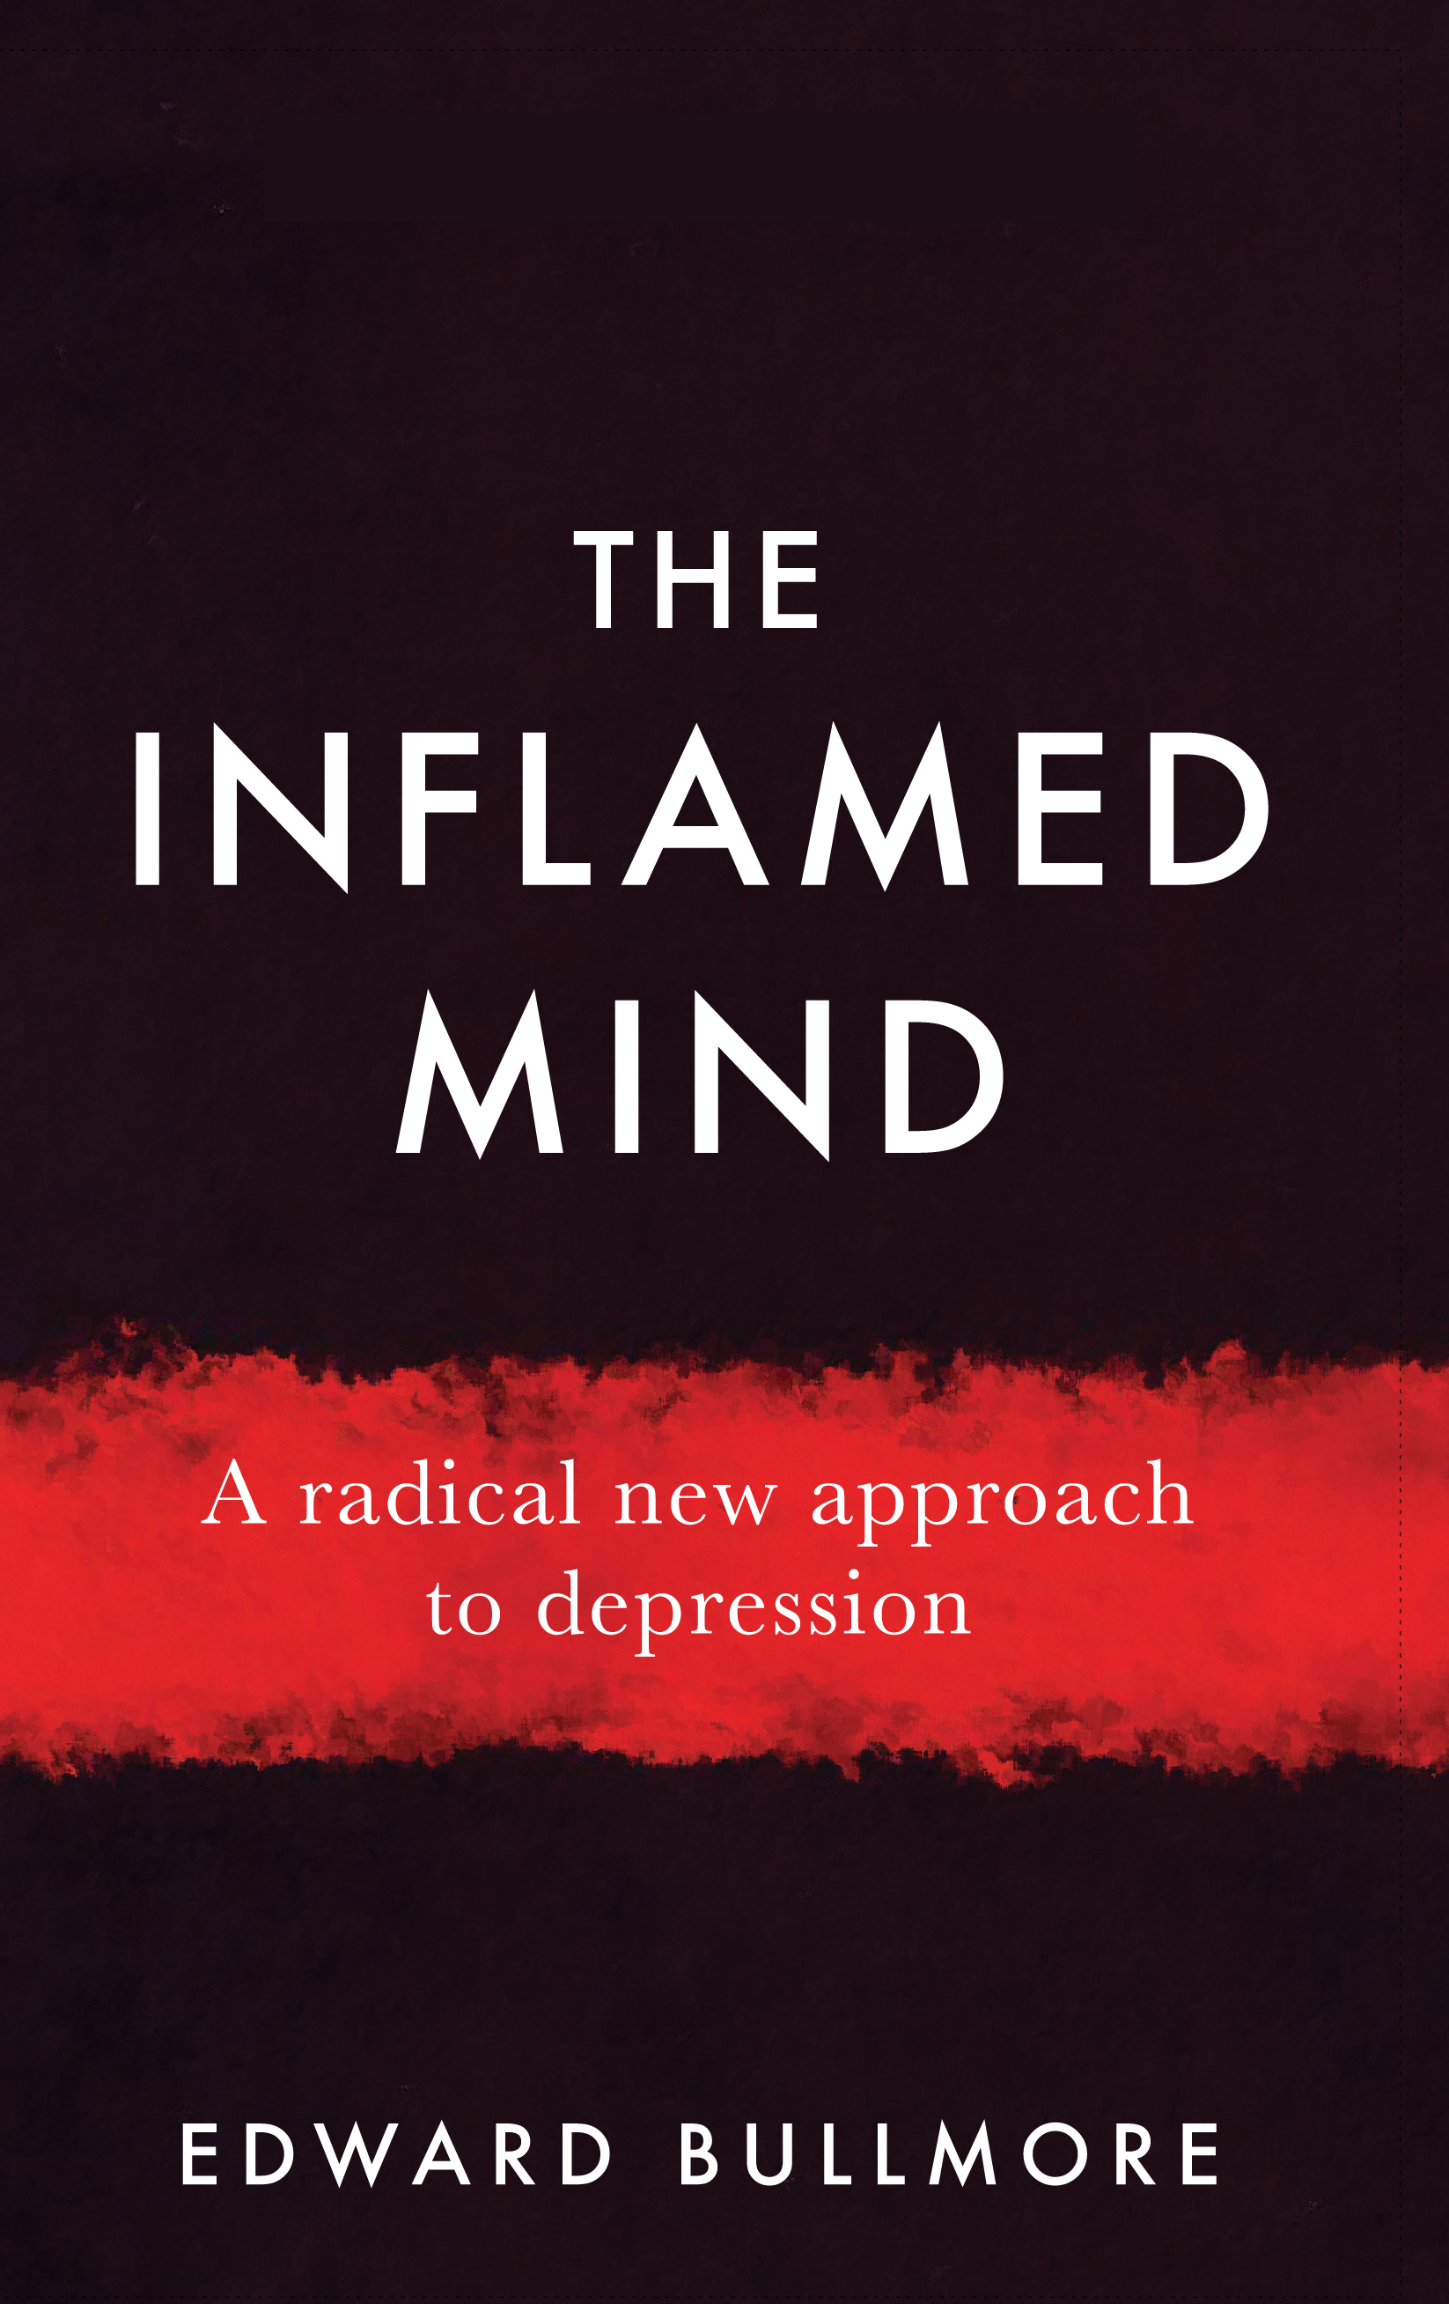

Worldwide, depression will be the single biggest cause of disability in the next 20 years. But treatment for it has not changed much in the last three decades. In the world of psychiatry, time has apparently stood still... until now.

In this game-changing book, University of Cambridge Professor Edward Bullmore reveals the breakthrough new science on the link between depression and inflammation of the body and brain. He explains how and why we now know that mental disorders can have their root cause in the immune system, and outlines a future revolution in which treatments could be specifically targeted to break the vicious cycle of stress, inflammation and depression.

The Inflamed Mind goes far beyond the clinic and the lab, representing a whole new way of looking at how mind, brain and body all work together in a sometimes misguided effort to help us survive in a hostile world. It offers insights into the story of Western medicine, how we have got it wrong as well as right in the past, and how we could start getting to grips with depression and other mental disorders much more effectively in the future.

Prof Edward Bullmore MB PhD FRCP FRCPsych FMedSci is Professor and Head of the Department of Psychiatry, University of Cambridge. He is a world expert in neuroscience and mental health, who is leading the development of new anti-inflammatory drugs for depression in partnership with industry.

