Foreword by Dr Michael Mosley
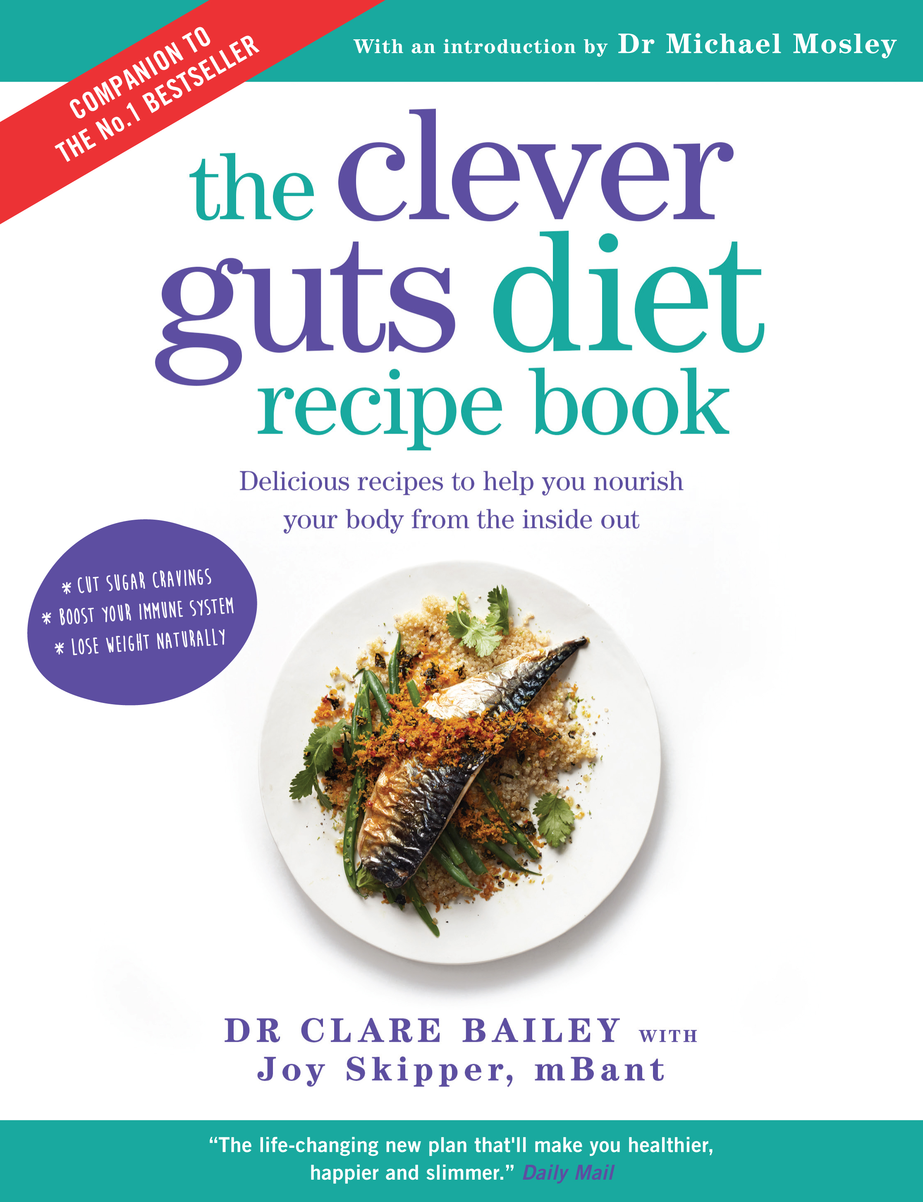

The companion recipe book to the No 1 bestseller – The Clever Guts Diet
the clever guts diet recipe book
Delicious recipes to help you nourish your body from the inside out

Dr Clare Bailey with
Joy Skipper, mBant

PUBLISHED IN ORIGINAL PAPERBACK BY SHORT BOOKS ON 16 NOVEMBER 2017 PRICE £14.99
STRICLY EMBARGOED UNTIL 11TH NOVEMBER 2017
“The life-changing new plan that’ll make you healthier, happier and slimmer.”
Daily Mail
Your gut is key to y​our ​physical and mental wellbeing ​ – home to your microbiome, an army of microbes that influences your weight, mood and immune system​.​
​In this companion book to Dr Michael Mosley's bestselling The Clever Guts Diet, Dr Clare Bailey, GP and wife of Dr Mosley,​ ​offers the definitive toolkit for bringing your gut back to optimum health. With 150 delicious recipes, ranging from healing broths and fermented food to enzyme-stimulating salads and meals rich in pre- and probiotics​, this book shows you how to reboot your microbiome with Dr Mosley's revolutionary two-phase gut ​repair programme​.
​Whether you ​are an IBS​ sufferer, have a food​ intolerance, or are ​simply looking t​o undo​ the damage done by processed foods and​ ​antibiotics​, The Clever Guts Diet Recipe Book​ is packed with ​nutritional information,​ ​meal planners and all the advice you need to mend your gu​t and boost your health and wellbeing​.
Dr Clare Bailey, wife of Michael Mosley, is a GP who has pioneered the Blood Sugar Diet approach at her own surgery in Kent, and is the author of the hugely successful 8-week Blood Sugar Diet Recipe Book. She has four children and a kitchen full of fermented food.
Joy Skipper is a qualified nutritionist who has worked in the food industry for over 20 years, writing cookery books and features as well as advising clients on healthy diet and lifestyle.
Dr Michael Mosley is a British journalist, scientist, producer and TV presenter.

Praise for The Clever Guts Diet:
“Dr. Mosley, one of the world's leading writers
covering nutrition and health, does it again with a
very informative and entertaining book. Follow his advice
for better gut health.”
Dr. Valter Longo
Director, University of S California Longevity Institute

FOR MORE INFORMATION OR TO REQUEST AN INTERVIEW OR REVIEW COPY PLEASE CONTACT
KATHERINE STROUD – kstroudpr@gmail.com / 07780112964

