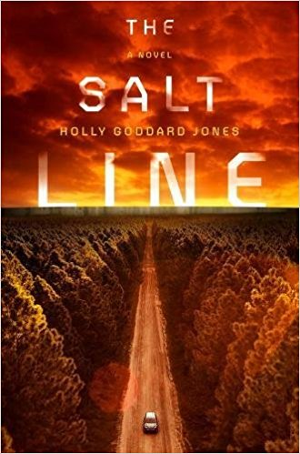
THE SALT LINE
A novel
by Holly Goddard Jones
How Far Will They Go For Their Freedom?

Published 5th September 2017
Putnam £18.99 hardback / £7.99 ebook

American writer Holly Goddard Jones garnered outstanding praise for her debut novel The Next Time You See Me in 2013. Kate Atkinson commented that the novel was “rich in character…immensely satisfying” and Gillian Flynn called it “mesmerising”. Jones returns this September with a gripping story of survival and humanity.
In an undisclosed future, the United States has been divided into zones with metropolitan borders receding behind “salt lines,” rings of scorched earth that protect citizens from a deadly disease-carrying tick. Those inside the salt line live a safe, comfortable life, and only extreme adventure seekers and adrenaline junkies journey beyond the line to the American wilderness. When one group of thrill seekers — each with his and her own agenda — ventures beyond the line, they quickly find themselves not only at the mercy of these deadly ticks, but held captive by a community of outer-zone survivors determined to protect their own existence.
Mirroring real-world issues from today’s headlines, THE SALT LINE features a wealthy businessman with menacing political aspirations, an insect carrying a deadly disease, a great physical and societal divide between the wealthy and disenfranchised, and a future where abortion is outlawed. Into this dismal world, Jones brings strong diverse female protagonists who dominate the plotline, controlling their own stories instead of furthering those of male leads.
About the Author:
Holly Goddard Jones is the author of The Next Time You See Me (debut novel 2013) and the story collection Girl Trouble. She was a recipient of the Fellowship of Southern Writers’ Hillsdale Award for Fiction and of a Rona Jaffe Foundation Writers’ Award. Jones lives in Greensboro, North Carolina and teaches creative writing at the University of North Carolina.
For review copies, interview requests and additional information please contact:
Becke Parker | becke@bparkerpr.co.uk | 07810 480924

Praise for Holly Goddard Jones’ The Next Time You See Me
“The Next Time You See Me is an astoundingly good novel. Holly Goddard Jones writes with authority and a deep generosity about a large swath of humanity within a small town: Outsiders and insiders, middle-schoolers and the middle-aged, the violent and the violated, the lost and the found—and all those in between. The result is simply mesmerizing.” – Gillian Flynn, author of Gone Girl
“So rich in character. I loved the subtlety and complexity of Wyatt and Sarah, and of course, Susanna,
the whole thing woven deftly together with a light hand. An immensely satisfying and skillful debut novel." – Kate Atkinson, author of Life After Life

"Impressive . . . An eerie air hangs over the novel, but Ms. Jones has a talent for making even scenes apart from the central mystery feel suspenseful. She also has a precise eye and empathy to burn, bringing each of her many characters to well-rounded life.” – New York Times

"If you're yearning for a genre-defying novel filled with mystery and suspicion, who better to provide a recommendation than author Gillian Flynn, whose wonderfully bizarre Gone Girl also defies categorization . . . What this novel does is align and then intertwine the lives of these characters, fascinating us with their psyches and, let's face it, sad and sorry lives. . . Their stories aren't pretty, but Jones lays them out in a beautifully articulate way.” – USA Today 3 ^{1/2} stars

