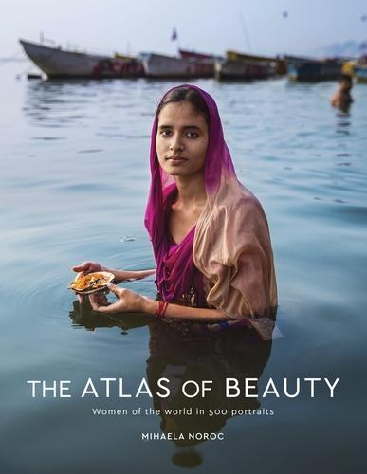
THE ATLAS OF BEAUTY
Women of the world
in 500 portraits
MIHAELA NOROC

Published by Particular Books | 1st October 2017 | Hardback £25

‘Stunning . . . aims to challenge the ideals of beauty dictated by the women's fashion magazine industry’ Independent
The Atlas of Beauty is a mirror of our diverse societies and an inspiration to all women to remain authentic, showing that beauty has no rules. It contains 350 photographs of women from over 50 countries, with captions that reveal each woman’s unique story and environment. Since 2013 Mihaela Noroc has travelled the world with her backpack and camera taking photos of everyday women to showcase the diversity and beauty all around us. The Atlas of Beauty is a collection of her photographs that celebrate women from all corners of the world and shows that beauty is everywhere, regardless of money, race or social status, and comes in many different sizes and colours. Noroc's portraits feature women in their native environments, from the Amazon rain forest to markets in India, London city streets and parks in Harlem, to remote rural communities such as North Korea. She visually demonstrates the juxtaposition between the varied built and social worlds these women inhabit.

‘A startling and revealing project’ Daily Mail

‘Scrolling through 'The Atlas of Beauty', beauty becomes not a universal standard, but a complicated tapestry’ Huffington Post

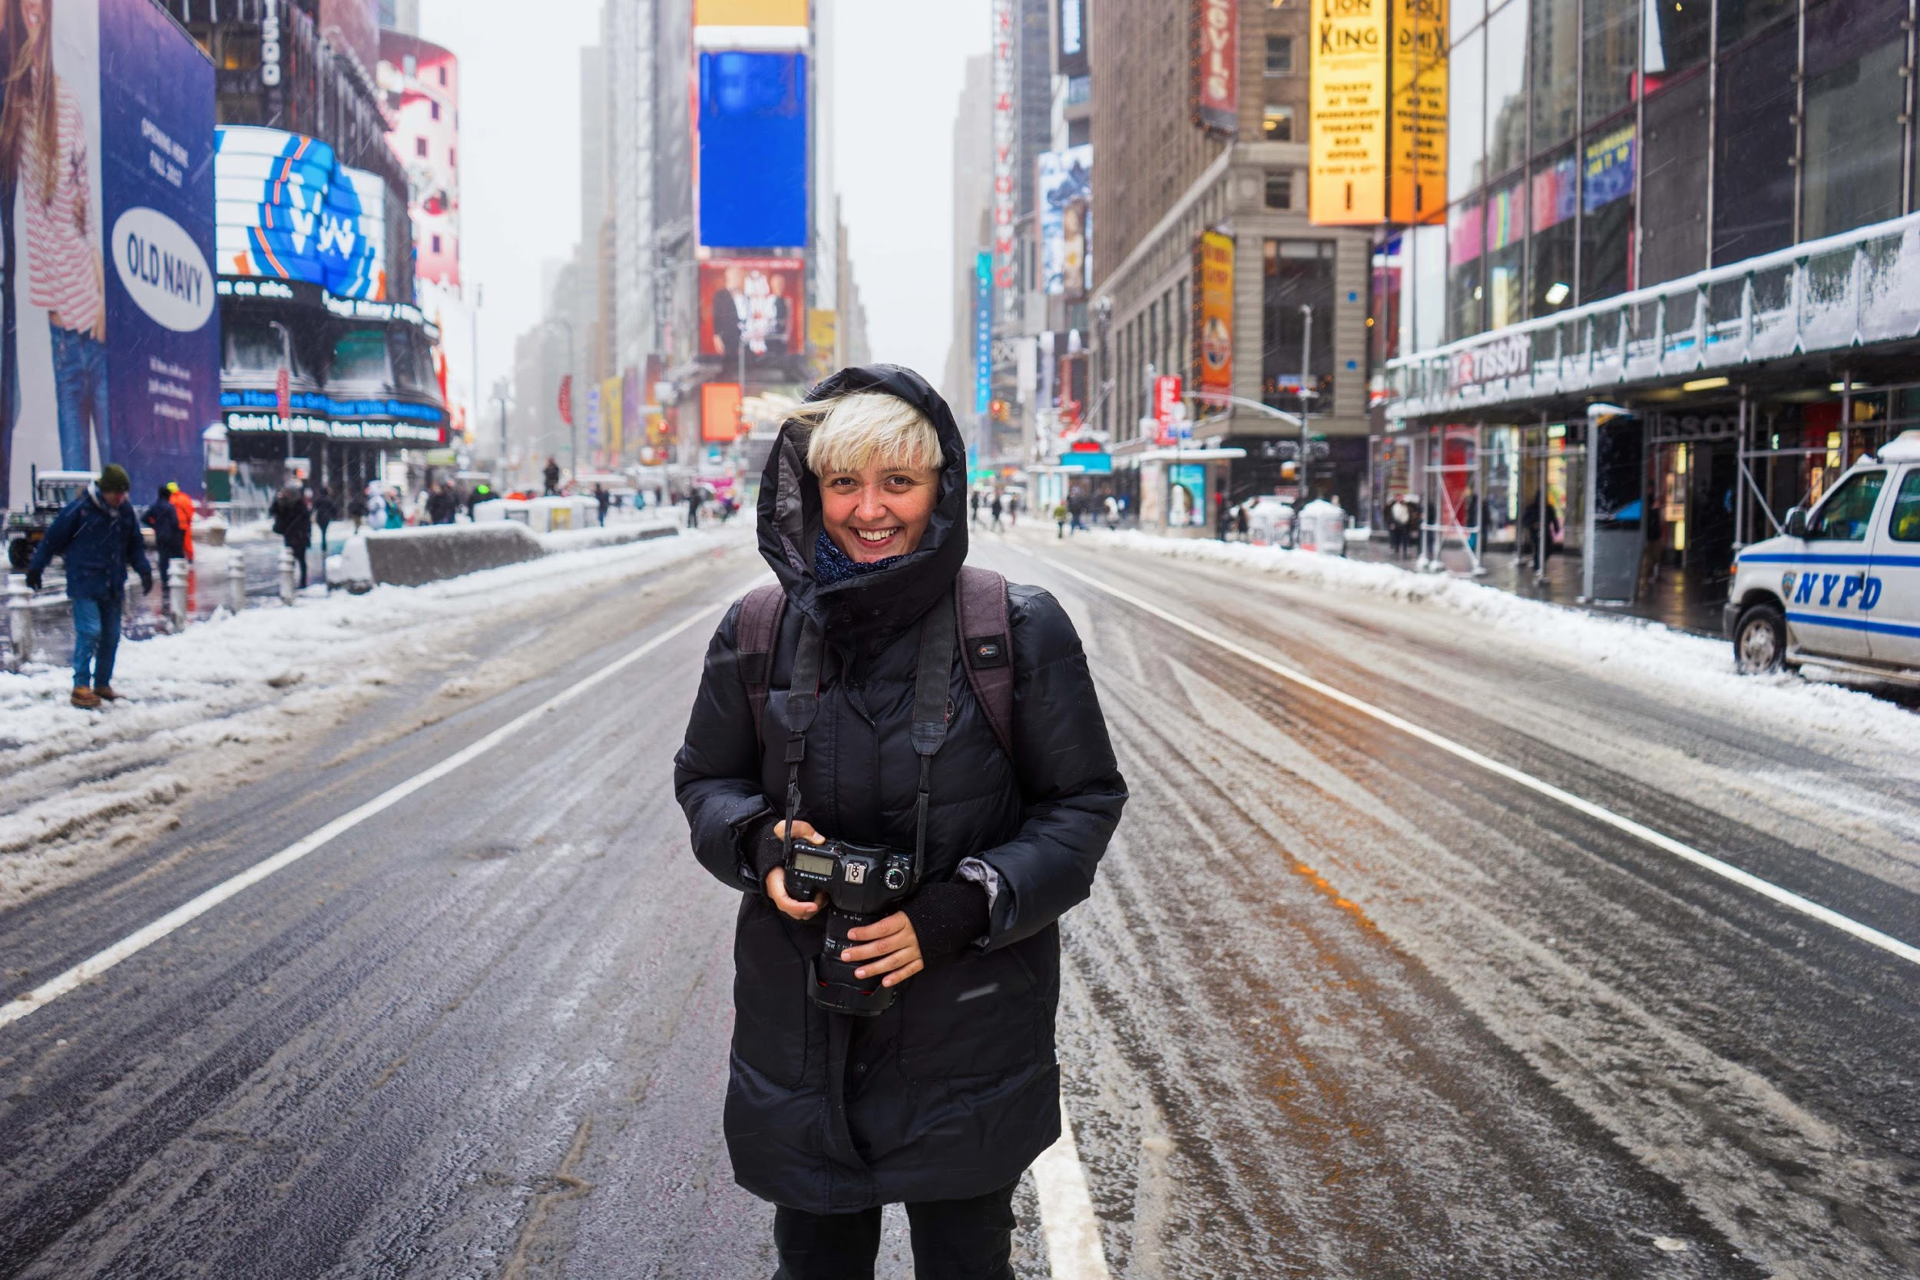
About the author…
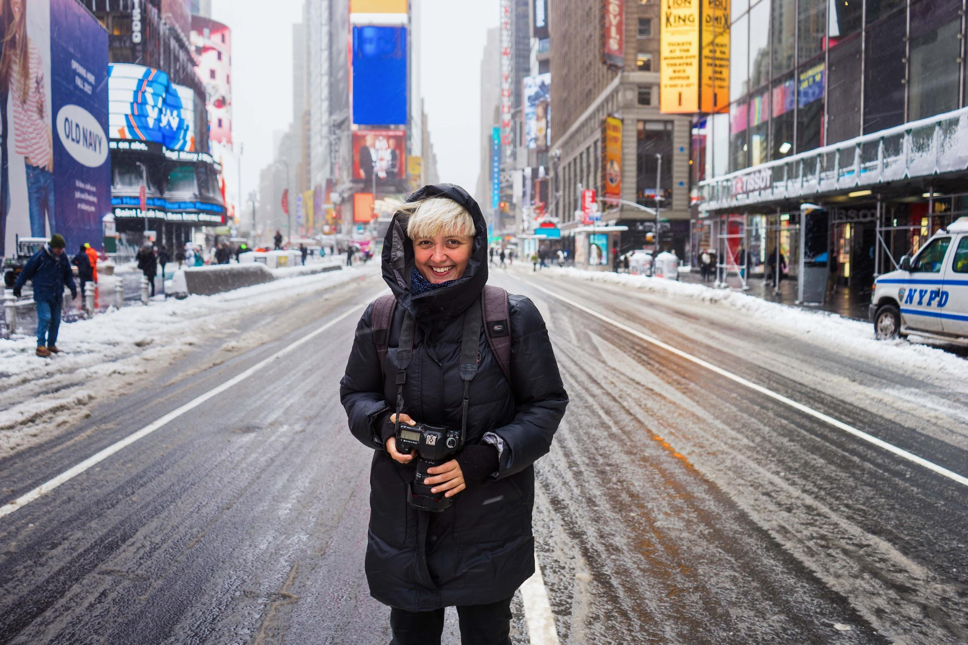

Over three years ago, Mihaela Noroc left her life in Romania and set off around the world with her camera. She has been travelling ever since and her photo blog now attracts over one million followers. The Atlas of Beauty is her first book.

Find out more about Mihaela’s work here: www.theatlasofbeauty.com / Twitter: @mihaela_noroc / Instagram: @the.atlas.of.beauty.

Press contact: Katherine Stroud | kstroudpr@gmail.com | 07780112964

