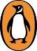
PRESS RELEASE

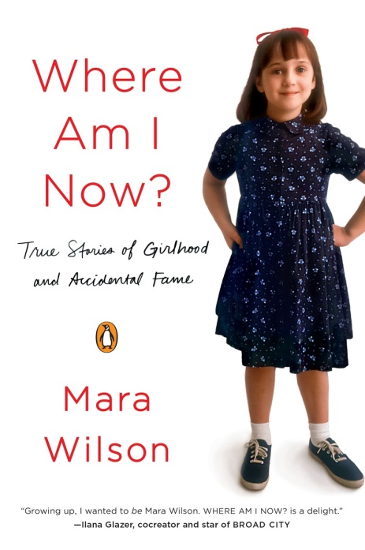
Where Am I Now?
True Stories of Girlhood and Accidental Fame

Mara Wilson

A Penguin Original
Published on 22nd September
£11.99 Paperback & ebook
EMBARGOED UNTIL SEPTEMBER 13TH

Introducing a witty, perceptive and refreshingly candid new literary voice - Mara Wilson, the beloved child star of Matilda and Mrs Doubtfire, writes openly about her experiences growing up on film sets and finding her place in the world.
Mara Wilson has always felt a little young and a little out of place: as the only child on a film set full of adults, the first daughter in a house full of boys, the sole clinically depressed member of the cheerleading squad, a valley girl in New York and a neurotic in California, and an adult the world still remembers as a little girl. Tackling everything from how she first learned about sex on the set of Melrose Place, to losing her mother at a young age, to getting her first kiss (or was it kisses?) on a celebrity canoe trip, to not being cute enough to make it in Hollywood, these essays tell the story of one young woman s journey from accidental fame to relative (but happy) obscurity. They also illuminate a universal struggle: learning to accept yourself, and figuring out who you are and where you belong.

Exquisitely crafted, revelatory, and full of the crack comic timing that has made Mara Wilson a sought-after live storyteller and Twitter star, Where Am I Now? is a funny, poignant and daringly honest collection of personal essays.

From Where Am I Now?
AGE TWENTY-THREE My obsession with death has waned... I can now watch a YouTube video of puppies playing and not immediately think, ‘It’s really sad those puppies will have to die someday’. I’m still not fond of the idea of dying, but it’s not my sole preoccupation. Now that I have to worry about things like paying bills on time, feeding my cats, and where I put my Social Security card, I don’t have time to worry about the heat death of the universe. Mara Wilson writing in Where Am I Now?
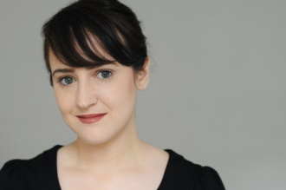

Mara Wilson is a writer, playwright, actor and storyteller, well -known as the little girl from Mrs Doubtfire, Miracle on 34th Street, and Matilda. She regularly appears at live storytelling and comedy shows, including her own, What Are You Afraid Of? Her writing can be found on Jezebel, The Toast, McSweeney's, The Daily Beast and Cracked.com, along with her own blog MaraWilsonWritesStuff.com. Mara lives in New York City.

"Every time Mara Wilson opens her mouth, we like her even more." The Huffington Post

"Wilson is more compelling as an adult than she was a child. Her writing is sharp, funny, and critical of
the film industry and expectations placed on women who live their lives in public." - Longreads.com

"The coolest girl to ever dump Hollywood." -Refinery 29

"Growing up, I wanted to BE Mara Wilson. I always loved that she portrayed strong characters, especially as a female, even as a young child. Where Am I Now? is a delight." - Ilana Glazer, co-creator and star of Broad City

"Former child star Mara Wilson has grown up to be a moving, funny, and thoughtful storyteller. Well, not up. As I understand it, she's still approximately the same height." -Megan Amram, comedian and author of Science . . . For Her!

"You don't have to be a fellow neurotic Jew who grew up in Southern California to adore this book. Though Mara Wilson's childhood was unique, the themes of Where Am I Now? are universal." -Rachel Bloom, creator and star of Crazy Ex-Girlfriend

Mara Wilson is available for interview

All UK publicity enquiries and review copy requests to Becke Parker:
email becke@bparkerpr.co.uk / tel 07810 480924

