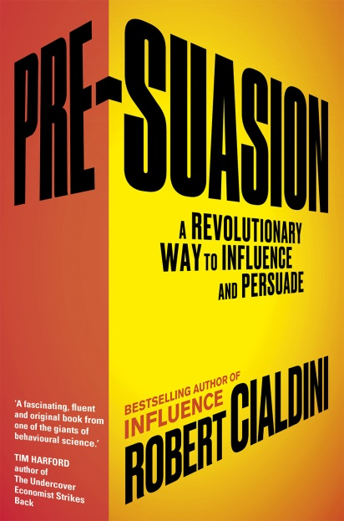
Pre-Suasion

A Revolutionary Way to Influence and Persuade

Robert Cialdini
Random House Books, 8 September
£18.99 hardback / eBook £9.99

A revelatory exploration of the science of persuasion from the author of the international bestseller Influence

In his ground-breaking new book Professor Robert Cialdini offers revelatory new insights into the art of winning people over. It isn’t just what we say or how we say it that counts, he argues, but also what goes on in the moments before we speak. Effective persuasion requires effective pre-suasion.
Professor Cialdini’s New York Times bestselling book Influence was originally published in 1984, and swiftly established him as the world’s foremost authority on the science of persuasion. It has now sold over 3 million copies and been translated into 30 languages. Warren Buffett has declared Influence to be among his favourite business books, and it has also won plaudits from such major thinkers and writers as Daniel Kahneman, Daniel Pink, Tom Peters and Chip Heath. It is not surprising, therefore, that Professor Cialdini is frequently regarded as the ‘Godfather of influence’.
Pre-Suasion draws on a series of compelling case studies and a profound understanding of human psychology to explore those key seconds that determine the success of an attempt to influence, persuade or win over. As such it will be of invaluable practical help to people such as advertisers, publicists, fund-raisers, recruiters – even parents negotiating with recalcitrant children. At the same time it will reveal to the general reader the pre-suasive ploys used by successful influencers – from marketers to politicians – to ensure that their message gets across.
The chapters detail:

- How to recognise ‘privileged moments’: identifiable points in time when an individual is particularly receptive to a communicator’s message
- What types of marketing effort and consumer product review are most successful. Why, for example, should on-line photographs of fluffy clouds help sell furniture?
- Why our perception of what is important can so easily be shifted, and how the US government used this to their advantage during the Iraq War
- Which triggers are most effective, from the verbal (there is a linguistic, not just musical, reason why ‘Like a Rolling Stone’ has been voted the greatest pop song of all time by some) to the physical (the layout of an examination hall can influence candidates’ results)
- When attempts to persuade dishonestly backfire: why, for example, company employees encouraged to mislead customers often end up defrauding their own organisation
About the author: Professor Robert Cialdini has spent his entire career researching the science of influence, earning him an international reputation as an expert in the fields of persuasion, compliance and negotiation, and making him the most cited living social psychologist in these areas. The Harvard Business Review calls him the ‘leading social scientist in the field of influence’. As well as his bestselling books, his ground-breaking research has been featured in the most prestigious scientific journals as well as on TV, radio and in the business and national press throughout the world. He is currently Regents’ Professor Emeritus of Psychology and Marketing at Arizona State University.
Professor Cialdini is CEO and President of INFLUENCE AT WORK (www.influenceatwork.co.uk) which focuses on ethical influence training and corporate keynote programmes. His clients include Google, Microsoft, Cisco Systems, Coca Cola, Ericsson, Kodak, Merrill Lynch, Nationwide Insurance, Pfizer, AAA, IBM, Prudential, The Mayo Clinic, GlaxoSmithKline, Harvard University, The Weather Channel, The United States Department of Justice and NATO. He has given seminars to the British government on effective communication, while his company’s advice to the NHS to help tackle the problem of patients not turning up for appointments (which costs the NHS £700 million a year) led to a 31.4% decline in no-shows.
Professor Robert Cialdini will be in London, 10–13 October
and is available for interview

For further information, please contact Becke Parker on 07810 480924
email becke@bparkerpr.co.uk

Advance praise for Pre-Suasion:

‘A fascinating, fluent and original book from one of the giants of behavioural science.’ Tim Harford, author of The Undercover Economist Strikes Back
‘It’s a book that is guaranteed to be a bestseller among marketeers, but it should also be a must-read for any professional or consumer – in other words, all of us.’ David Halpern, CEO, the Behavioural Insights Team, author of Inside the Nudge Unit
‘The great social psychologist Robert Cialdini has written another timeless and indispensable book about the psychology of influence. I’ll be recommending it for years and years.’ Amy Cuddy, author of Presence
‘An utterly fascinating read on how the most important drivers of persuasion aren’t the words we choose in the moment, but how we set the stage beforehand. Robert Cialdini is the world’s foremost expert on influence, and you will never look at it the same way again.’ Adam Grant, author of Originals and Give and Take
‘No social psychologist’s research has been used more often or successfully than that of Robert Cialdini, who literally “wrote the book” on influence. Now, he’s done it again, showing us the power of the moment before an attempt to persuade. This is classic Cialdini – authoritative, original, and immediately practical.’
Richard H. Thaler, co-author of Nudge and author of Misbehaving

‘There are single sentences in this book that are worth the purchase price on their own. I loved it." Rory Sutherland, Vice-chairman of the Ogilvy Group, UK

