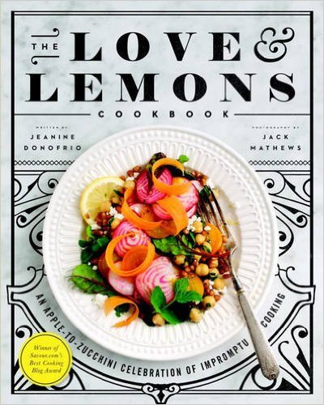
THE
LOVE & LEMONS
COOKBOOK

written by
Jeanine Donofrio

Photography by
Jack Mathews

Hardback £25.00
Published by Avery
21st April 2016

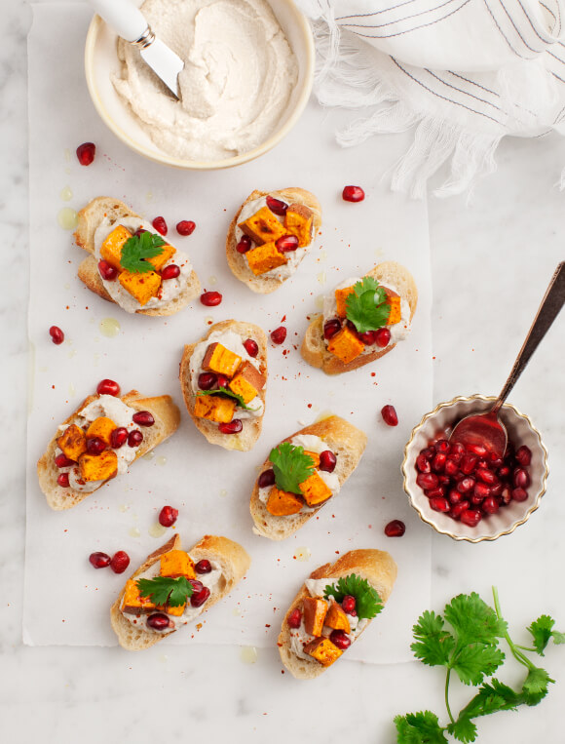

The long-awaited debut cookbook from the creator of the immensely popular LOVE & LEMONS blog

The Love & Lemons blog has taken the online foodie world by storm. Its standout design and delicious recipes have attracted buzz from everyone from Yotam Ottolenghi to Saveur. Now, in her highly anticipated debut cookbook, creator Jeanine Donofrio celebrates seasonal and impromptu cooking with more than 100 all-new, delicious vegetarian recipes.
Donofrio's cooking philosophy is that simple combinations can make exceptionally delicious meals that are easy to put together. Rather than going to the shops, recipe in hand, Donofrio shares how to cook a meal around what you already have at home. Organised by ingredient, THE LOVE & LEMONS COOKBOOK will show how to make beautiful food with whatever is in your cupboard, whether it's a bunch of carrots from the farmers market or a huge cauliflower that just showed up in your veggie box. Recipes include Butternut Squash Red Curry, Heirloom Tomato Panzanella, Loaded Sweet Potato Nachos, Spring Leek & Lemon Pasta, Crispy Shiitake BLT, Chipotle Apple Guacamole and Blueberry Mango & Mint Ice Cream.
With exquisite fresh food photography and stylish layouts, THE LOVE & LEMONS COOKBOOK is a resource that readers will find themselves referring to again and again.

Jeanine Donofrio is the voice behind Love & Lemons - a cooking and lifestyle blog inspired by vibrant seasonal food. She creates the recipes, her husband helps taste-test and together they photograph their food from their sunny kitchen in Austin, Texas. Donofrio's goal is to inspire her readers to get creative with vegetables, whether they're vegan, gluten-free or just love good food. In addition to winning 2014 Best Cooking Blog by Saveur magazine, Donofrio has been featured in Redbook, Foodandwine.com, Food52, Refinery29, Self and many more US publications.

The Love & Lemons blog can be found at: www.loveandlemons.com

FOR RECIPE EXTRACTS and FURTHER INFORMATION PLEASE CONTACT:
Becke Parker: becke@bparkerpr.co.uk / 07810 480924
www.prcollective.co.uk

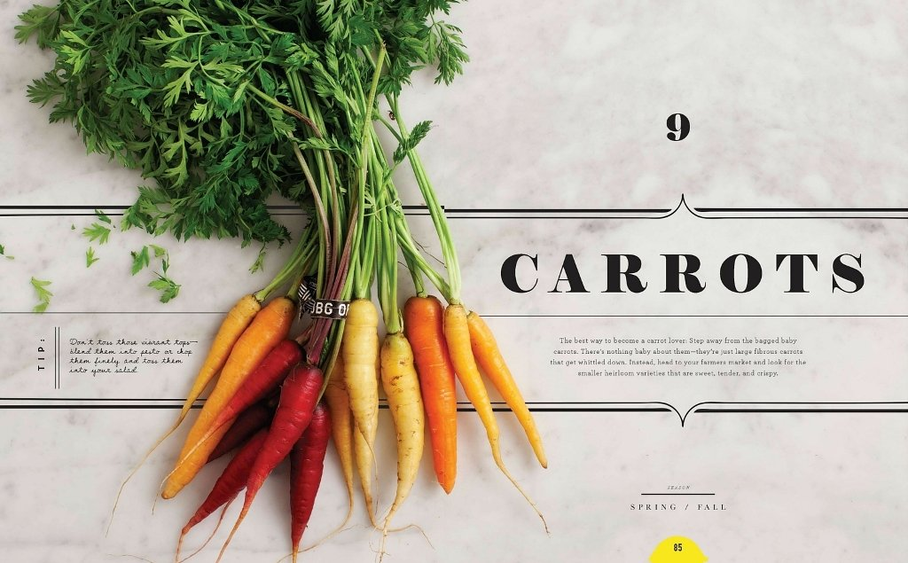
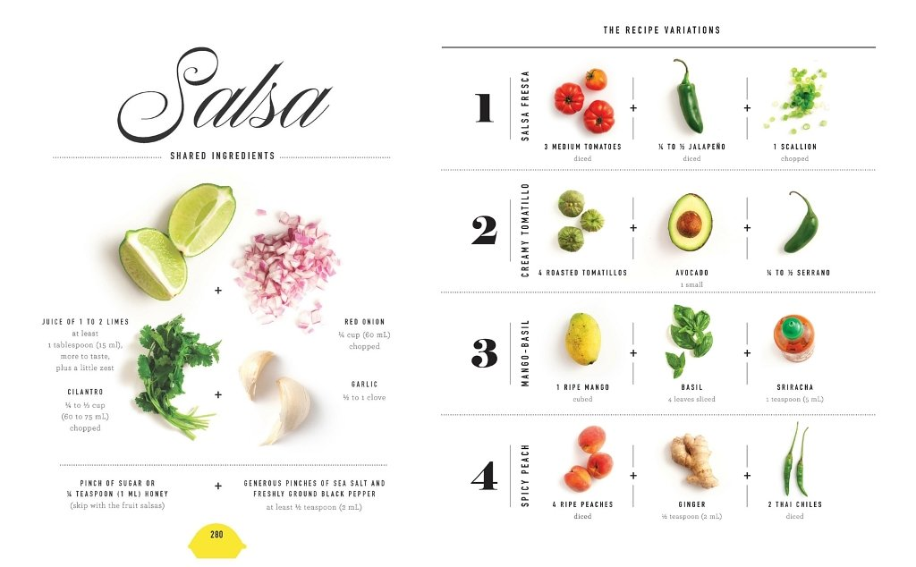

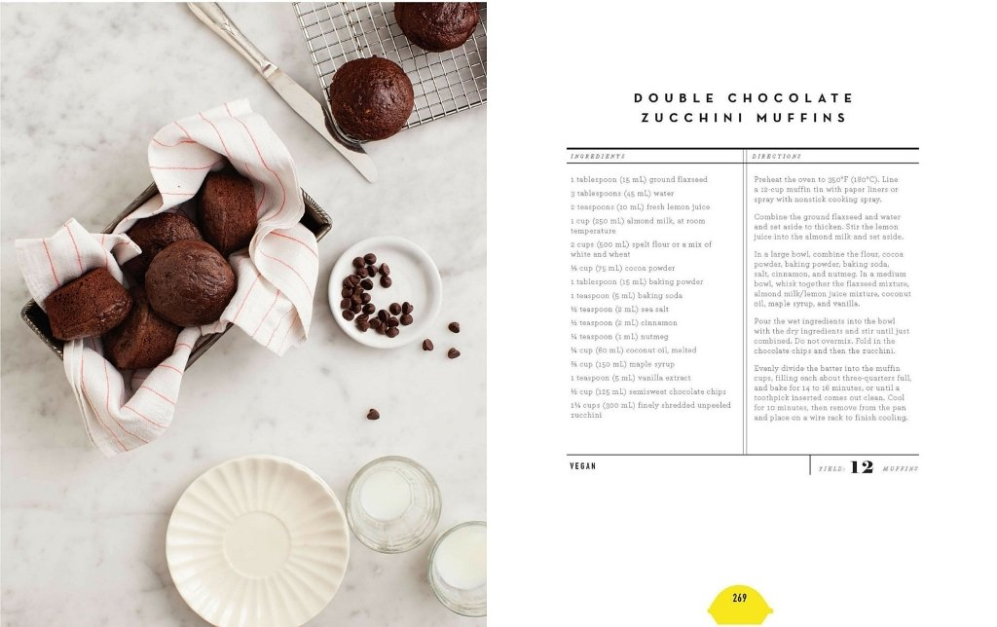
FOR RECIPE EXTRACTS and FURTHER INFORMATION PLEASE CONTACT:
Becke Parker: becke@bparkerpr.co.uk / 07810 480924
www.prcollective.co.uk

