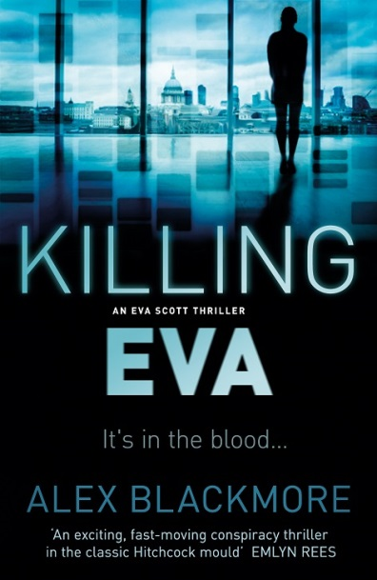
KILLING EVA
AN EVA SCOTT THRILLER

Alex Blackmore

No Exit Press
Paperback original £7.99 & ebook £5.99
Published November 26th
ebook £5.99
‘An exciting, fast-moving conspiracy thriller in the classic Hitchcock mould’ – Emlyn Rees
Introducing a gripping new voice and the formidably authentic protagonist Eva Scott
Eva drew back from the dying man. His breath was hot on her face, the grip he had on her wrist was tight, but she knew that he had just moments left.

Witnessing a dramatic death at London's Waterloo Station triggers a series of events that shatter Eva
Scott's world. Dying words uttered on the station concourse awaken a history she had thought long
buried. But the past is about to be resurrected, in all its brutal reality.
Eva's life is soon out of her hands. A genetic key is keeping her alive; but foreshadowing her death.
People from her past materialise and then disappear, testing the limits of her sanity. Inextricably linked to her survival is the potential takedown of an economic power, on which hang the lives of many others. The only way out is through . . But Eva's life is no longer her own . . And it's killing her.

Alex Blackmore’s second novel confirms her place on the thriller scene. A fast-paced conspiracy with an impressive female lead, Killing Eva ensures that Blackmore will be an author to watch.
Alex Blackmore runs The Glass Pineapple, an online fashion retail start-up championing emerging designers and independent labels to be launched in Autumn 2015. As well as writing novels, Alex also manages her own copywriting business. Alex spent five years in the pressure cooker environment of City law, in both Paris and London, before breaking free of the egos and unending document piles to write. Her debut novel, Lethal Profit, was published by No Exit in 2014.
Alex is currently based in London and Winchester.
Find out more at www.alexblackmore.com @AlexPBlackmore

Praise for Alex Blackmore’s debut thriller Lethal Profit:
Alex Blackmore is available for interview, features and events
All publicity enquiries and review copy requests to Becke Parker:
email becke@bparkerpr.co.uk / tel 07810 480924

All publicity enquiries and review copy requests to Becke Parker:
email becke@bparkerpr.co.uk / tel 07810 480924

“This is immensely lively fare, delivered with a skill that belies the fact that this is the author's first novel” - Crime Time
“A down-and-dirty tale of survival, a la Taken; a hi-tech corporate thriller; a '70s style political conspiracy; a Bond-style spy drama. That’s a heady, intoxicating mix.” - Crime Thriller Fella
“An exciting, fast-moving conspiracy thriller in the classic Hitchcock mould” - Author Emlyn Rees
“Alex has forged a unique tale” - Mystery People
“A real page turner... one to watch!” - Best Crime Books to Read
“Clever and enjoyable... Recommended” - Amanda Gillies, eurocrime
“Dedication and perseverance paid off” - Adrian Magson
READER REVIEWS for Lethal Profit:
Offer me another Alex Blackmore and I will snatch it from your hands in glee!!
The character of Eva is cleverly put together and the author has left the way open for a second book
A must read book for the summer, Eva Scott gets in to more and more danger as the plot thickens, the twists in this book keep the reader hooked.
This is a rollercoaster of a ride and best read in one sitting as I could not put this book down
I couldn't stop turning the pages of this fast-paced thriller. It's an action-packed and exciting book and the cleverly interwoven stories left me breathless. I can't wait to see what happens next!
Excellent book, could not put it down. Blood pressure took time to settle down after reading.
Exceptional for a debut writer
Great suspense, and a strong female lead!

