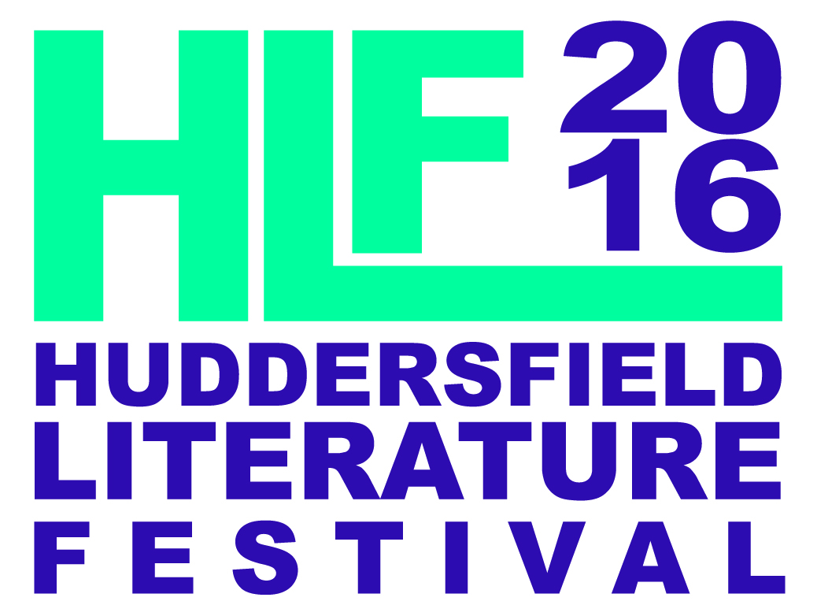

Huddersfield Literature Festival Marks Ten Years

As it celebrates its 10th year, the 2016 Huddersfield Literature Festival promises to be the best yet. The 2016 Festival also marks the centenary of the birth of Harold Wilson in Huddersfield, and the bi-centenary of the birth of Charlotte Bronte.

Irvine Welsh, explorer Levison Wood, Joanne Harris, actor and comedian Ben Miller, theatre critic Michael Billington, poet and playwright Lemn Sissay, Christopher Fowler, Rupert Thomson, Claire Harman, Milly Johnson and Egyptologist Joann Fletcher are all appearing this year. Alan Johnson MP will present the annual Harold Wilson Lecture, in partnership with the University of Huddersfield and the Diocese of West Yorkshire and the Dales.

The Festival runs from 3rd – 13th March, with some events taking place before and after these dates. A Big Screen Family Day, John Peel Pub Quiz, Writing and Publishing Workshops, Mother’s Day event with stand-up Kate Fox, events for National Libraries Day, LGBT events, Open Mic Night and Poetry Competition ensure that the tenth anniversary will truly be celebrated in style.

For the full programme visit: www.litfest.org.uk/

The HLF is committed to providing accessible events and some events this year will have live subtitling by Stagetext to give deaf, deafened and hard of hearing audiences access to events.

Festival authors and performers are available for interview

For further details please contact:
Becke Parker
email: becke@bparkerpr.co.uk
tel: 07810 480924

About the HLF
Since its inception in 2006, the Huddersfield Literature Festival has provided innovative and high-profile events to support and showcase both established and new, emerging writers and performers, as well as offering the opportunity to attend workshops and masterclasses. The Festival is a not-for-profit organisation; funding is sourced from ticket sales, grants and sponsorship and it is committed to paying its performers. Michelle Hodgson is Festival Director. Author, poet and playwright Lemn Sissay and actor Patrick Stewart are patrons of the Festival.

