The *New York Times* bestselling author draws from the hugely popular *#AskGaryVee Show*



to offer surprising, often outrageous, and imminently useful and honest answers to everything

you’ve ever wanted to know – and more – about navigating the business and digital world.

**#ASKGARYVEE**

**One Entrepreneur’s Take on Leadership,**

**Social Media & Self-Awareness**

**by Gary Vaynerchuk**

**Published by Harper Business on 17 March**

**£20 hardback**

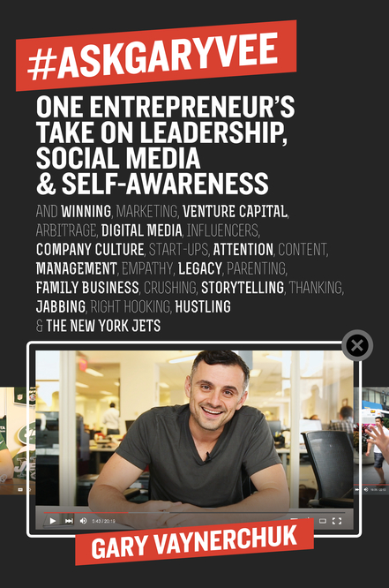

***“Hello, everyone, and welcome to the first #AskGaryVee*.”**

So began a web show on YouTube on July 31, 2014. Its host, social media and business expert Gary Vaynerchuk, answers questions about business, marketing, social and digital media, online campaigns, motivation, management and much much more – shooting from the hip and always refreshingly honest, cutting through corporate speak to instantly resonate with his huge international fan-base.

In his new book, Vaynerchuk showcases the most useful and interesting queries he has presented on the show, along with never-before answered questions. Vaynerchuk started out in 2006 with Wine Library TV and has since built the digital media agency VaynerMedia which helps Fortune 500 companies tell their stories via digital and social media.

**#ASKGARYVEE** is the master class every professional needs, addressing a host of subjects from launching start-ups, building personal brands and leveraging social media, to questions about leadership, hiring and firing, public speaking, and the best ways to combine family life with business. But unlike a traditional education, Vaynerchuk writes, “I don’t want you to regurgitate what you learn. I want you to act on it right now.” Going even deeper on answers provided in his popular show and addressing timely new questions, the book offers the most up-to-date insights on social media platforms, the larger media and technology industry, and how to excel and get people’s attention. Vaynerchuk also makes it personal, revealing what he has learned not just in his role as an entrepreneur and marketer, but also as a leader, manager, and family man.

For anyone starting their own company, working in the digital ad and marketing world, or simply looking for some straightforward business (and life) advice, **#ASKGARYVEE** has the answer.

**ABOUT GARY VAYNERCHUK**

**Gary Vaynerchuk** is a New York Times bestselling author, entrepreneur, and self-trained social media expert. Straight out of college he took his [family wine business](http://www.winelibrary.com/) and grew it from a $3M to a $60M business in just five years. CEO and co-founder of VaynerMedia, Vaynerchuk is also a prolific angel investor and venture capitalist, who invested early in companies including Facebook, Twitter, Tumblr, Uber, and Birchbox before co-founding [Vayner/RSE](http://vaynerrse.com/) in 2014, a $25M angel fund that invests in and helps launch the next generation of world-changing technology companies. Vaynerchuk was named in Fortune magazine’s “40 under 40” list of the most influential leaders in business in 2014, and in 2015 appeared in Crain’s “40 under 40” list, recognising New York’s top business leaders. In 2016 VaynerMedia will open their first international office in London.

**Gary Vaynerchuk is available for interview**

**Extracts and video content from #ASKGARYVEE are available**

**For all UK press enquiries, please contact Becke Parker**

**on 07810 480924 or email becke@bparkerpr.co.uk**