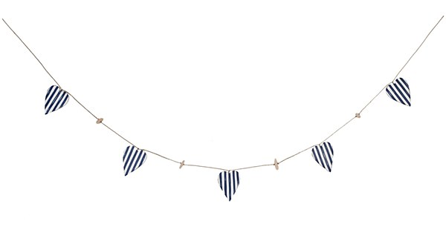

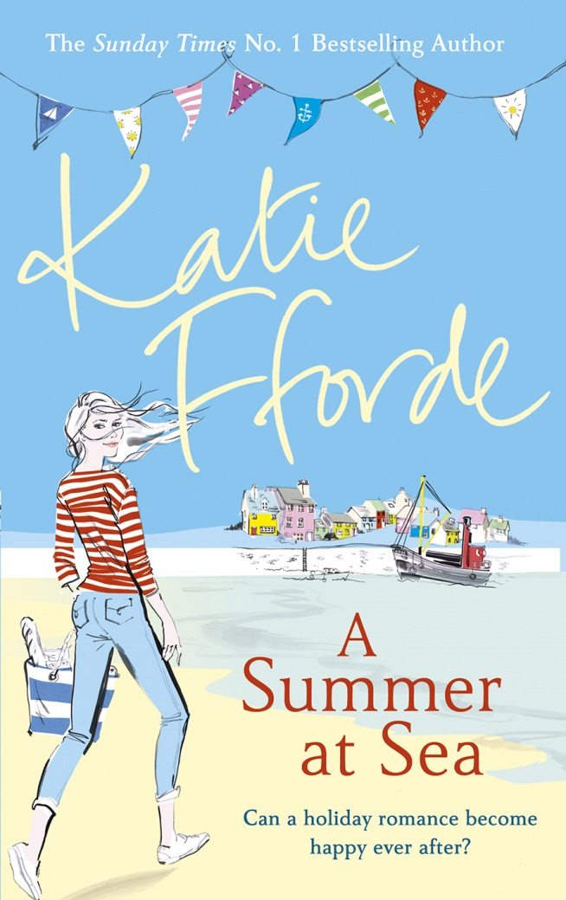



**A Summer at Sea**

Published 11th February 2016 | Hardback, £12.99 and ebook

Emily is happy with her life just as it is. She has a career as a midwife that she loves. She enjoys living on her own as a single woman. But she also feels it’s time for a change, and perhaps a spot of sea air. So when her best friend Rebecca asks whether she’d like to spend the summer cooking on a ‘puffer’ boat just off the Scottish coast, she jumps at the chance.

But she barely has time to get to grips with the galley before she finds herself with a lot on her plate… Rebecca is heavily pregnant and is thrilled to have her friend on board doing most of the work. Then there’s Emily’s competitive and jealous kitchen assistant who thinks she should be head-cook, not Emily.

And there’s Alasdair, the handsome local doctor who Emily is desperately trying not to notice. Because if she falls in love with him, as he appears to be falling for her, will she ever want her old life back again?

With characteristic humour and a happy-ever-after ending, *A Summer at Sea* is the deliciously romantic new novel from No. 1 Sunday Times bestselling author Katie Fforde.

Praise for Katie Fforde:

‘Modern-day Austen. Great fun’ ***Red***

‘If you're after an escapist novel that fizzes with warmth and wit, then this is perfect’ ***Daily Express***

‘Delicious – gorgeous humour and the lightest of touches’ ***Sunday Times***

‘A lovely, warm read to sink your teeth into’ ***Heat***

‘A wonderful warm-hearted escapist read – just the thing for a lazy afternoon’ ***Woman & Home***

‘A perfect match for an afternoon curled up on the sofa!’ ***Sun***

**Win a Katie Fforde escape with Joules!**

To celebrate the publication of Katie Fforde’s new books *A Summer at Sea* and *A Vintage Wedding*, we have teamed up with Joules to offer a lucky winner a weekend away at the Manor House Hotel in the Cotswolds with a bag full of Katie Fforde books and Joules products!

To enter go to facebook.com/KatieFforde or facebook.com/Joules. Closing date 26.2.2016. Terms and conditions apply.

**Note to editors**:

* The boat in *A Summer At Sea* is a real boat based in Crinan, round the Highlands and Islands in Argyle. Its real name is VIC 32 but it is known as the Puffer. The Puffer is an historic craft with a huge fan base of holiday-makers and will be selling *A Summer At Sea* on board. Katie can talk about her holidays on this boat. <http://savethepuffer.co.uk/>
* Katie and her family have a holiday home on Loch Tay in Perthshire and she can write about her Scottish connections.

**Katie Fforde** lives in the beautiful Cotswold countryside with her family, and is a true country girl at heart. Each of her books explores a different profession or background and her research has helped her bring these to life. She’s been a porter in an auction house, tried her hand at pottery, refurbished furniture, delved behind the scenes of a dating website, and she's even been on a Ray Mears survival course. She loves being a writer; to her there isn’t a more satisfying and pleasing thing to do. She particularly enjoys writing love stories. She believes falling in love is the best thing in the world, and she wants all her characters to experience it, and her readers to share their stories. A regular top five Sunday Times bestseller, Katie Fforde has sold 2.5 million books in the UK alone.

To find out more about Katie Fforde step into her world at www.katiefforde.com, visit her on Facebook and follow her on Twitter @KatieFforde.

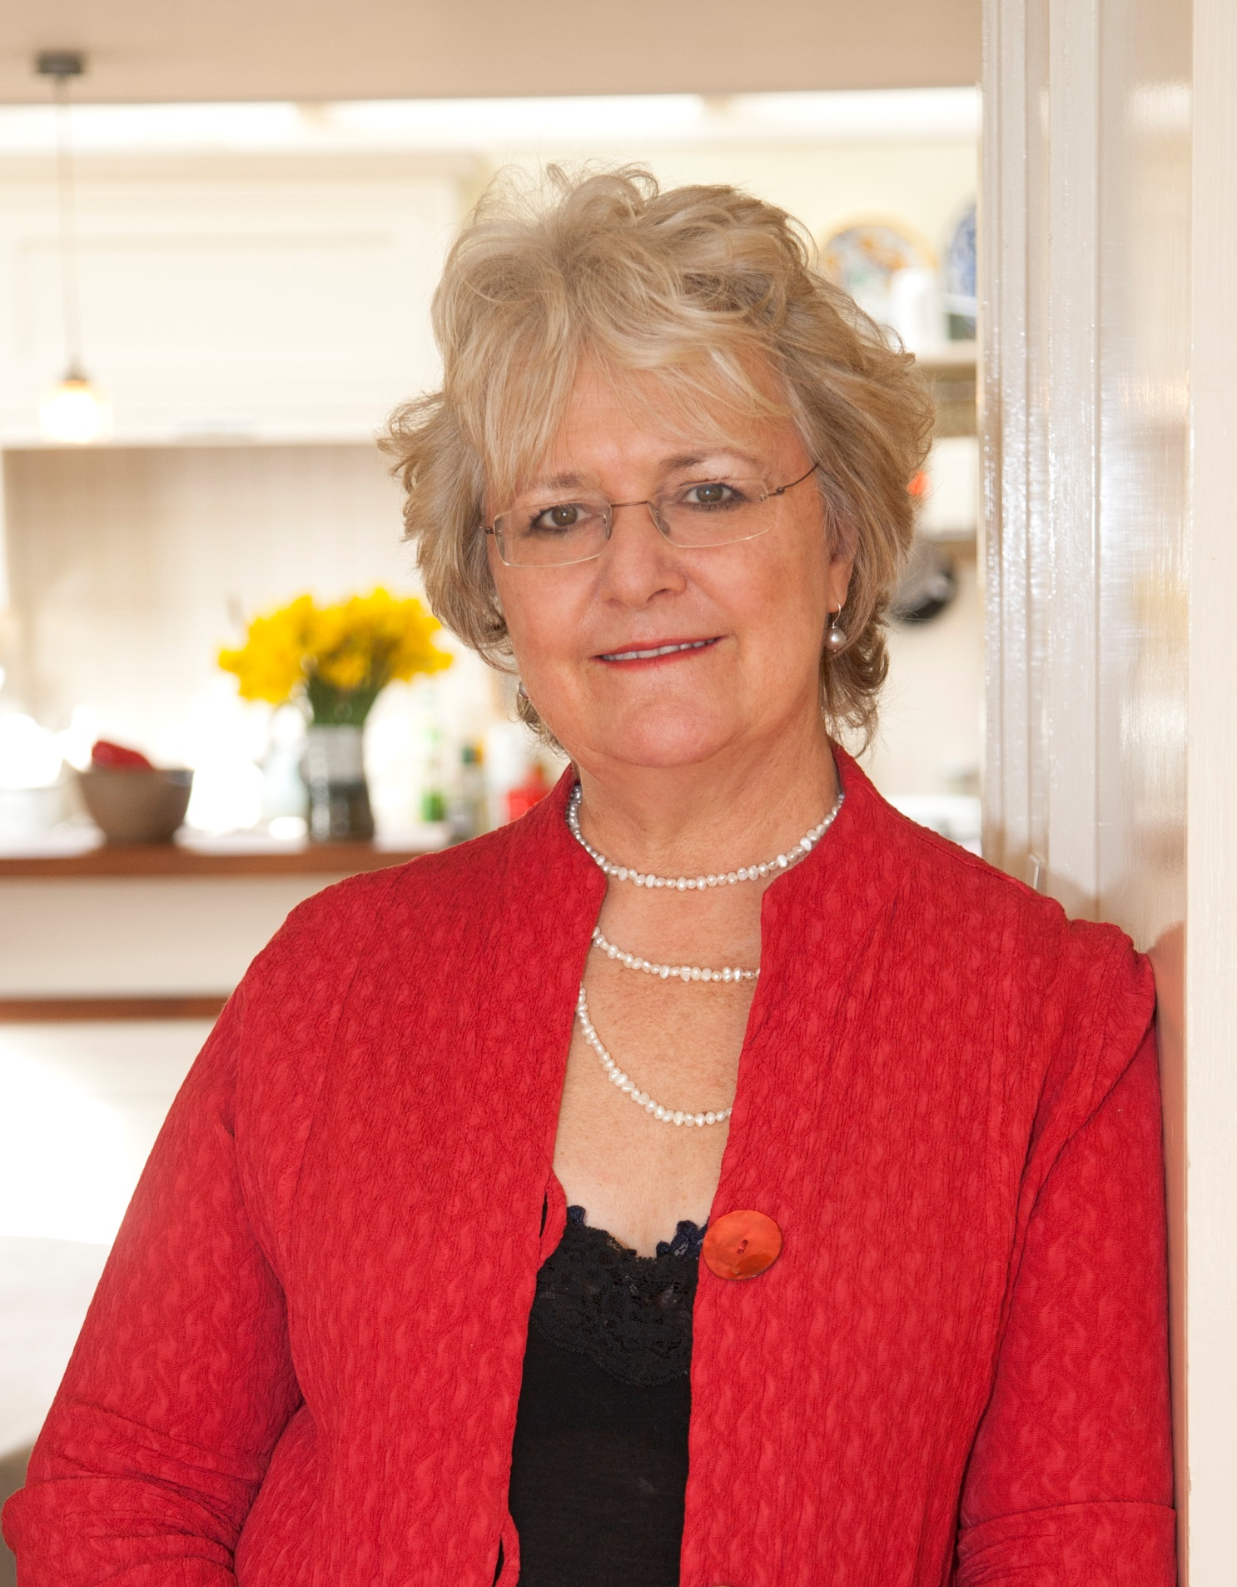

**Katie is available for interview and to write features**

Please contact Becke Parker 07810 480924 | bparker@penguinrandomhouse.co.uk | @beckep24

