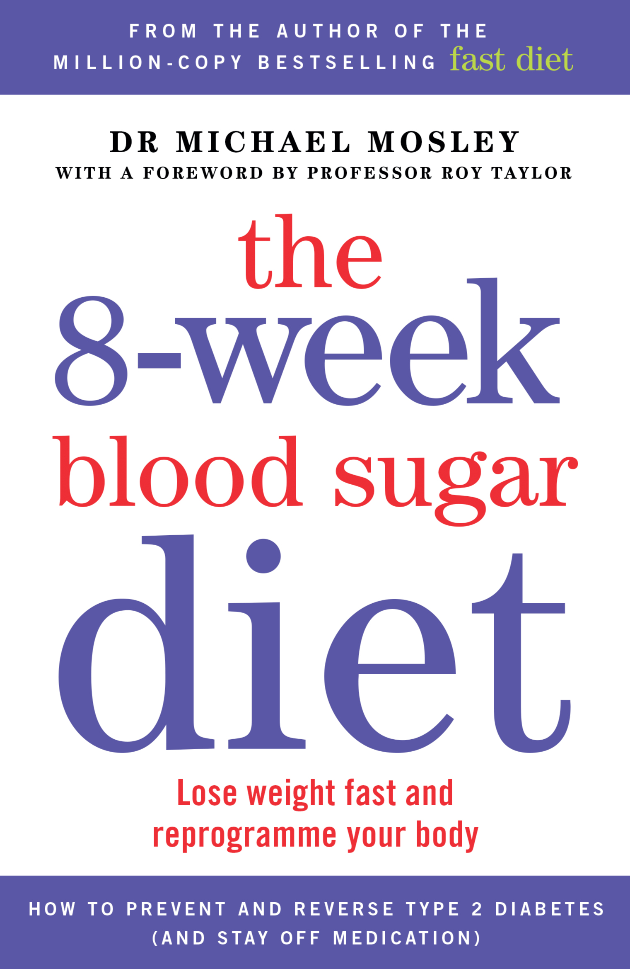
From the author of the million-copy bestselling Fast Diet

The 8-week Blood Sugar Diet

Lose weight fast and reprogramme your body

Dr Michael Mosley

With a foreword by Professor Roy Taylor

PUBLISHED BY SHORT BOOKS IN B FORMAT PAPERBACK ON 16TH JANUARY 2016, £8.99

Dr Michael Mosley, author of the bestselling 5:2 Fast Diet, reveals a game-changing approach to one of the greatest silent epidemics of our time – raised blood sugar levels.
The food we eat today, high in sugar and easily digestible carbohydrates, is not only making us fat, but is putting us at risk of type 2 diabetes, strokes, dementia, cancer and a lifetime on medication. More than a third of adults in the UK now have raised blood sugar levels and most don’t know it.
In this timely book, Dr Mosley explains why we pile on dangerous abdominal fat and shows us how to shed it, fast. He demolishes common myths, such as the claim that steady weight loss is always better than rapid weight loss and that those who lose weight rapidly will inevitably put it back on.
This is a book not just for those at highest risk but for anyone who has struggled with their weight and wants to regain control of their health.

Dr Michael Mosley is a British journalist, scientist, producer and TV presenter. Professor Roy Taylor is Professor of Medicine and Metabolism at Newcastle University.

“I feel amazing. I have been given another chance at life.” – Cassie, 28 – lost 20kg

POINTS FOR DISCUSSION:

• Average weight loss: 14kg in 8 weeks

• Not just a diet book, it will become a state of the nation talking point about the obesity epidemic that is beginning to drown the NHS.

• The book includes first-hand accounts from numerous people who have already benefited from Professor Taylor’s method, and details the evidence that has convinced the sceptics.

• Dr Mosley is making a series of films both of himself and his recruits to be released on YouTube around publication.

