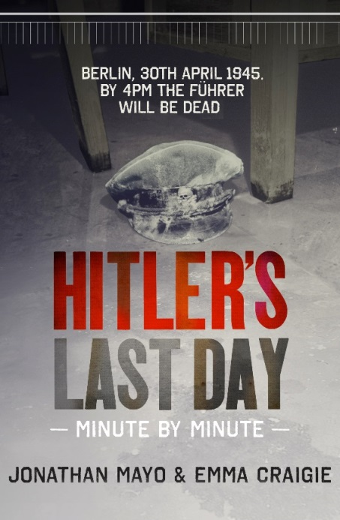
HITLER’S

LAST DAY

MINUTE BY MINUTE

Jonathan Mayo & Emma Craigie
Published 23rd April 2015, £14.99
“Beyond fascinating… this book brings to life a thousand different people in the most dramatic moment of the last century.” Jeremy Vine
‘As Hitler ended his life, hundreds of thousands of people across the world were trying to save theirs. Their world was indeed hell. That one man could be the cause of such suffering that almost defies belief. This is their story.’

Hitler’s Last Day: Minute by Minute is pure chronological narrative of events taking place worldwide on 29th and 30th April 1945; as seen through the eyes of those who were there in the bunker, those waiting for news back home, or fighting in the streets of Germany, or pacing the corridors of power in Washington, London and Moscow.

Sisi Wilczek is fleeing the advancing Russians with her family’s vast fortune in a shoebox; President Truman is weighing up the consequences of using the atomic bomb that his Secretary for War calls ‘the most terrible weapon ever known in human history’; German officer Rudolf Weiss is fleeing Berlin by stealing a canoe from a boat club; and Allied aircrews are tying parachutes to their own food parcels so they can drop them to the starving Dutch population.

American and Russian forces have linked up in the middle of Germany, but the fighting continues. The roads of Germany are full of people – Jews who have survived concentration camps, Allied POWs trying to get home, and Nazis on the run. The civilian population under German control will run out of food in less than a fortnight. The man whose dream of a thousand-year Reich began this nightmare is in a bunker beneath the streets of Berlin saying his farewells. By 4pm he will be dead.

THE AUTHORS
Jonathan Mayo joined the BBC in 1987, first working in radio and then television, where he won awards for his documentaries. He is the author of The Assassination of JFK: Minute by Minute and D-Day: Minute by Minute. He lives in Surrey with his wife and son.
Emma Craigie is a writer and teacher. She is the author of Chocolate Cake with Hitler and Henry VIII The Exploding King. She lives in Somerset with her husband and four children.

FOR MORE INFORMATION PLEASE CONTACT:
Katherine Stroud: kstroudpr@gmail.com / 07780 112964
Becke Parker: becke@bparkerpr.co.uk / 07810 480924

