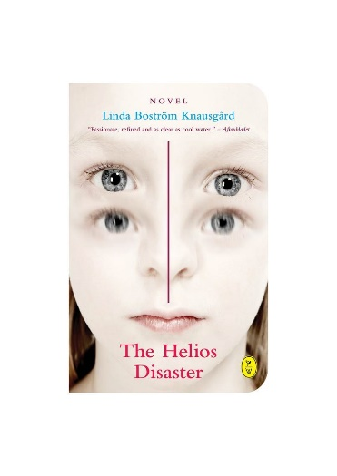
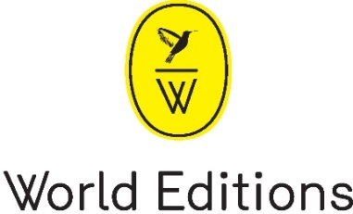

THE HELIOS DISASTER
By Linda Boström Knausgård
Translated by Rachel Willson-Broyles
Published on 26th February 2015, paperback £9.99
Linda Boström Knausgård narrates this mythical tale of mental illness with a tension so powerful and poetic that it recalls Ken Kesey’s One Flew Over the Cuckoo’s Nest and Patrick McGrath’s Asylum.

“Passionate, refined and as clear as cool water.” Aftonbladet
“‘Reading The Helios Disaster takes only couple of hours but it has a lasting, haunting effect. The spirit and language of this novella are so intense that it is almost scary. Anna/Athena is a character you are doomed to live with the rest of your literary life.”
Petri Stenman, Like Publishing (Finland)
“It is simple and it is grand, the story about the girl who came too close to the sun. The Helios Disaster shines!” Kulturnytt, Sveriges Radio P1 (Swedish public radio)
“Linda Boström Knausgård has been compared to Ali Smith, Jeanette Winterson and has also been called “a modern Brontë sister” Dutch leading newspaper De Volkskrant
The Helios Disaster is a contemporary mythical tale about mental illness in which a father gives birth to a twelve-year-old girl, splitting his head open in the process. Father and daughter are separated. The girl is placed into foster care and comes under the spell of the Pentecostal movement. When she starts speaking in tongues, she’s admitted to a psychiatric ward. All the time, she longs to meet her father and eventually they run away together. The author’s passionate involvement with her protagonist illuminates what it is like to slide away from reality and into a near-psychotic state.
The Helios Disaster was awarded the Mare Kandre Award 2013 and nominated for the Swedish Radio Novel Award 2014; Translation rights have also been sold to Sweden, Norway, Finland, Denmark and The Netherlands.
Linda Boström Knausgård (Sweden, 1972), is an author and a poet, she made her critical breakthrough in 2011 with the short-story collection Grand Mal. The Helios Disaster is her first novel. Linda Boström Knausgård is married to Karl Ove Knausgård.

The author will be in the UK on 23/24 February and is available for interview.
FOR MORE INFORMATION PLEASE CONTACT
katherine@prcollective.co.uk / kstroudpr@gmail.com / 07780112964

