Gliding Flight Anne-Gine Goemans
Translated from Dutch by Nancy Forest-Flier

WORLD EDITIONS · 12th February 2015 · £9.99 · ebook available

“The Dutch Annie Proulx” Opzij
Inventive, dreamy Gieles lives with his father and a flock of geese on a spotters’ campsite beside an airstrip. The fourteen-year-old boy is longing for affection from his mother, who is always on hopeless missions to save the world from starvation. He seeks company from a mysterious dreadlocked girl he has met online, or his gargantuan friend Super Waling who tells Gieles all about the history of the landscape they both inhabit. As the houses in the area are threatened with destruction because of noise regulations the relationship between Gieles’ parents begins to deteriorate and the boy conceives a desperate plan to reconnect them.

Gliding Flight is the second novel of Anne-Gine Goemans (born in the Netherlands 1971). The novel was awarded the Dioraphte Literary Prize and the German M Pionier Award for new literary talent (previously award to Herman Koch and Jonas Jonasson), and will be made into a film in 2015.

Both Gliding Flight and Goemans’ first novel Unfurrowed Ground (not yet published in English) were longlisted for the prestigious Libris Literatire Prize.

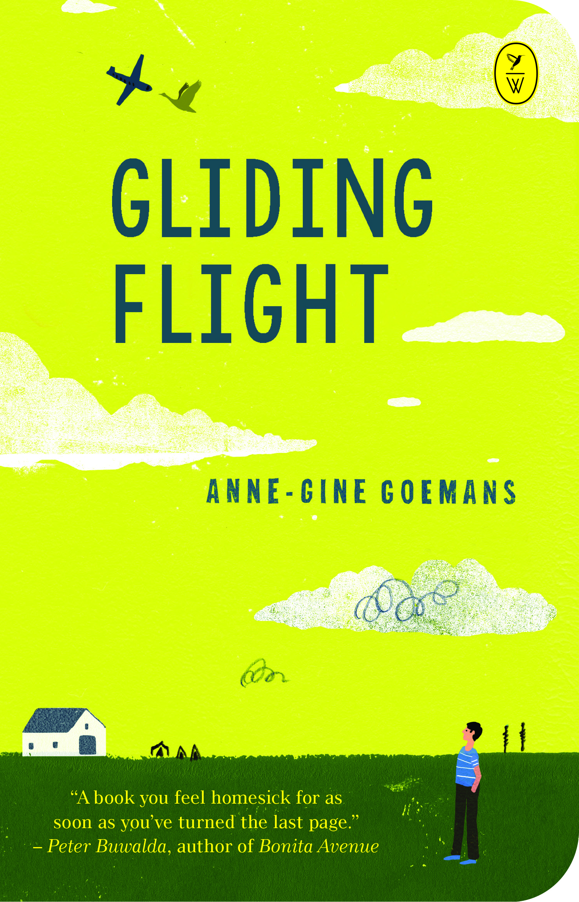

“A book you feel homesick for as soon as you’ve turned the last page.”
Peter Buwalda, author of Bonia Avenue
“Goemans shows, once again, how agile a narrator she is.” Trouw

About the translator:
Nancy Forest-Flier (1949) studied English literature and creative writing at Hope College in Holland, Michigan. After moving to the Netherlands in 1982, Nancy and her husband Jim Forest began Forest-Flier Editorial Services. Nancy has translated for numerous Dutch museums, institutes and publishing houses. Her list of literary translations includes The King by Kader Abdolah and Dissident for Life by Koenraad de Wolf.

Anne-Gine Goemans WILL BE IN THE UK ON THE 19TH AND 20TH JANUARY AND IS AVAILABLE FOR INTERVIEW

For more information please contact Becke Parker, PR Collective
07810 480924 / becke@bparpkerpr.co.uk / @beckep24

