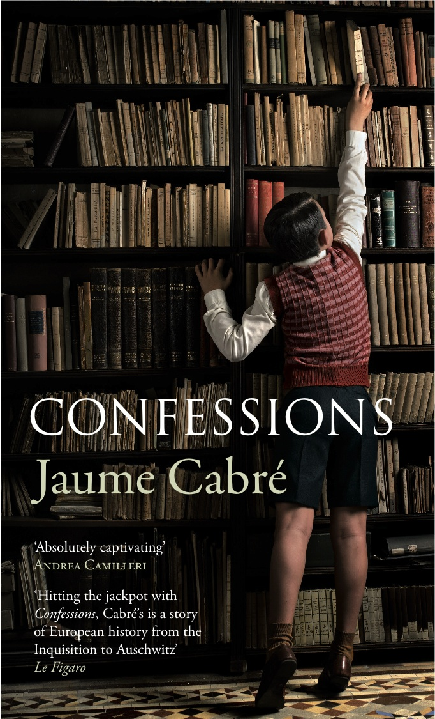
Jaume Cabré
CONFESSIONS
Translated from Catalan by Mara Faye Lethem
ARCADIA BOOKS / 30th October 2014 / Hardback £16.99 / 9781909807570
‘Absolutely captivating’ Andrea Camilleri
‘Hitting the jackpot with Confessions, Cabré’s is a story of European history from the Inquisition to Auschwitz’ Le Figaro

An instant bestseller in nine languages, Confessions is an astonishing story of one man’s life, interwoven with a narrative that stretches across centuries to create an addictive and unforgettable literary symphony. At 60, Adriá Ardévol re-examines his life before his memory is systematically deleted. He recalls a loveless childhood where the family antique business and his father’s study become the centre of his world; where a treasured Storioni violin retains the shadows of a crime committed many years earlier. His mother, a cold, distant and pragmatic woman leaves him to his solitary games, full of unwanted questions. An accident ends the life of his enigmatic father, filling Adriá’s world with guilt, secrets and deeply troubling mysteries that take him years to uncover. Ambitious, powerful and deeply moving, with an overwhelming theme of guilt and redemption, Confessions is a consummate masterpiece in any language, with an ending that will not just leave you thinking, but probably change the way you think forever.

Confessions is the winner of 10 awards including the Premio de la Critica and the Premi de la Criticia Serra d’Or. A No. 1 bestseller in 9 languages, Confessions is a majestic, page-turning, captivating masterpiece that examines the chronic violence that has defined humanity over centuries.

‘Its complexity turns Confessions into a piece of writing that has the power to influence our view of the world – a quality belonging to the best of literature’ El Mundo

Jaume Cabré is one of the most internationally celebrated contemporary Catalan writers. He is the author of a number of bestselling novels, with over a million copies sold throughout Europe, and has been awarded most of the Catalan literary awards. Confessions has been called a masterpiece of world literature by international reviewers, and received multiple awards.

FOR MORE INFORMATION PLEASE CONTACT A MEMBER OF PR COLLECTIVE

Katherine Stroud / 07780 112964 / Katherine@prcollective.co.uk
Rosamund Hutchison / 07886 6 18301 Rosamund@prcollective.co.uk
Becke Parker / 07810 480924 / Becke@prcollective.co.uk
Sue Amaradivakara / 07786 626492 / Sue@prcollective.co.uk

www.prcollective.co.uk

CATALAN AUTUMN 2014
This Autumn sees the publication of two other books by major Catalan writers

Joan Sales’ Uncertain Glory (translated by Peter Bush with a foreword by Juan Goytisolo) is published by Maclehose Press in the UK on 2nd October 2014. Contact Corinna Zifko on corinna.zifko@quercusbooks.co.uk for information.

Josep Pla’s The Gray Notebook (translated by Peter Bush) is published by New York Review of Books in the UK on 6 November 2014. Contact Emma O’Bryen on eobr@blueyonder.co.uk for information.

