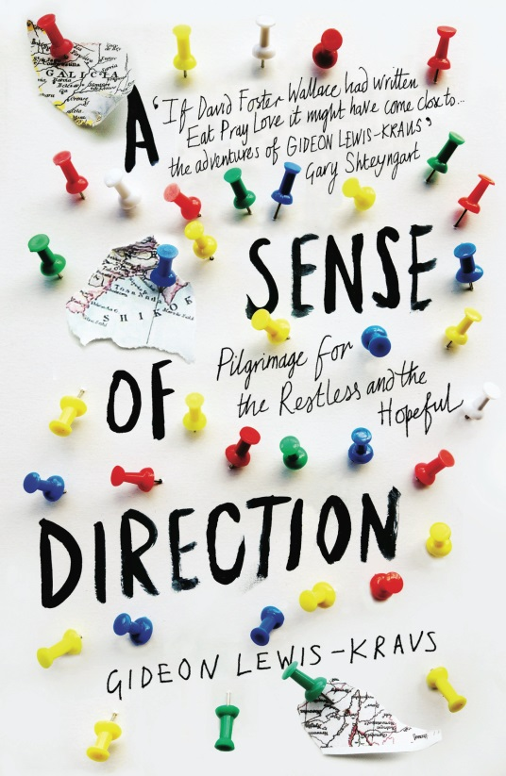
A SENSE OF DIRECTION
Pilgrimage for the Restless and the Hopeful
Gideon Lewis-Kraus
Published by ONE, an imprint of Pushkin Press on 30th January 2014
Paperback £8.99
'Beautiful, often very funny... a story that is both searching and purposeful, one that forces the reader, like the pilgrim, to value the journey as much as the destination.' The New Yorker
'Nails our collective anxiety - every sentence rings true... Lewis-Kraus is a master.' Daily Beast

“[I] and had moved to Berlin because I’d felt I was missing out on something exciting, and now I was on the brink of leaving lively, provisional Berlin because I was afraid I was missing out on something serious.” Gideon Lewis- Kraus sums up the yearning to counter the ennui of quarter-life with geographic upheaval.

And so, when Berlin offers only unfocused dissipation, frustration and anxiety; to find this “something serious” (though he’s not quite sure what it is), Gideon undertakes three separate ancient pilgrimages. He recounts his travels over hundreds of miles: the thousand-year old Camino de Santiago in Spain with a friend, a solo circuit of eighty-eight Buddhist temples on the Japanese island of Shikoku, and finally, with his father and brother, a migration to the tomb of a famous Hassidic mystic in the Ukraine.

It is on this last pilgrimage, and through writing this book, that Gideon reconnects with his father, a gay rabbi who came out in middle age, emotionally abandoning his sons. As he culminates his pilgrimages, it becomes clear that it is not the place, but the journey that can bring real clarity; as Gideon discovers that the most difficult and meaningful quest of all has been the journey of his heart.

Both succinctly funny and movingly honest, Gideon Lewis-Kraus examines with piercing insight our search for purpose in life, and how we travel between past and present in search of hope for our future.

Gideon Lewis-Kraus has written for numerous US publications, including Harper’s, The Believer, The New York Times Book Review, Los Angeles Times Book Review, Slate, and others. A 2007-8 Fulbright scholarship brought him to Berlin, a hotbed of contemporary restlessness where he conceived this book. He now lives in New York, but continues to find himself frequently on the road to other places.

FOR MORE INFORMATION OR TO REQUEST A REVIEW COPY PLEASE CONTACT KATHERINE STROUD / kstroudpr@gmail.com / 07780112964

