I CHOOSE ELENA
ON TRAUMA, MEMORY AND SURVIVAL
Lucia Osborne-Crowley
‘Startlingly intelligent, disturbing, profound and moving, I Choose Elena shows us that the #MeToo movement has grown roots, and that for survivors of rape and sexual assault, the revolution is just beginning. Osborne-Crowley gives us darkness wrought in light and the hope she offers is as palpable as it is hard-won.’
April Ayers Lawson, author of Virgin and Other Stories

Published by The Indigo Press | 19 September 2019
A format paperback original with flaps | 978 1 99968 339 9 | £7.99 | eBook available
A searing essay about trauma, recovery and the true cost of sexual violence
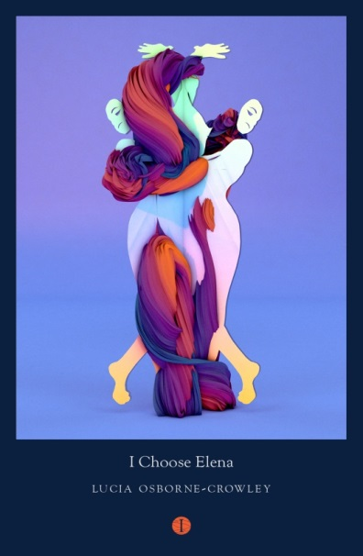
Lucia Osborne-Crowley’s childhood was spent pushing her body and her mind to their limits. An elite gymnast, by her ninth birthday she had represented her home state of New South Wales; by the time she was twelve she had represented Australia. She was on track to be an Olympian and every minute of every day was spent in pursuit of athletic perfection. Her self-belief was boundless; her determination unrelenting.At the age of 15, she was stopped in her tracks. Lucia was violently raped by a stranger on a night out, sparking a series of events that left her devastatingly ill for well into her adult life. She told no one about the rape. I Choose Elena is the story of how this trauma, borne in silence and fear, inhabited, tormented and threatened to destroy her once strong body. The long road to healing began a decade later when she shared her secret for the very first time. Finding solace in writers such as Elena Ferrante and Rupi Kaur, she learned how to express her suffering. And through words, she began to rediscover her resilience in the face of a formerly unbearable trauma.
I Choose Elena explores what has been proved, but is not yet widely known, about trauma, bringing to our attention its cyclical, intergenerational nature; how trauma intersects with deeply-held beliefs about the credibility of women; and how trauma is played out again and again in the fabric of our cultures, governments, judicial systems, and relationships. Lucia Osborne-Crowley has written an unforgettable book - eloquent, defiant and honest, it is the story of how a woman reclaimed her body.

Lucia Osborne-Crowley is a writer, journalist and lawyer. Her news reporting and literary work has appeared in ABC News, HuffPost UK, the Guardian, Meanjin, The Lifted Brow and others. She works as a legal academic in association with Essex Court Chambers in London and The University of New South Wales in Sydney. She lives in London. I Choose Elena is her first book. Lucia’s next book, My Body Keeps Your Secrets, will be published by The Indigo Press in 2020

Lucia Osborne-Crowley is available for events and media appearances
For further information, review copies and interview requests please contact:
Katherine Stroud: kstroudpr@gmail.com / +447780112964
Sue Amaradivakara: sue@prcollective.co.uk / +447786 626492

NOTES TO EDITORS

About The Indigo Press

The Indigo Press is an independent publisher of fiction and creative non-fiction, headquartered at the legendary John Murray building in London. Founded in 2017 by Susie Nicklin and Publishing Director Ellah Wakatama Allfrey, it brings together a conversation-starting curation of books offering bold ideas and beautifully crafted stories from around the world.

W: www.theindigopress.com T: @PressIndigoThe

About the MILD Group

Founded by CEO Susie Nicklin, MILD brings together a dynamic portfolio of book businesses that include award-winning independent bookshop Dulwich Books (founded in 1982), long-established international rights specialists The Marsh Agency (founded in 1994), publishing house The Indigo Press (founded in 2017), and LiveLit, a thriving year-round programme of events that includes three literary festivals. Each business operates individually whilst sharing expertise across their teams, for an enterprising approach to publishing from acquisition to retail and promotion.

W: www.mildgroup.co.uk
T: @TheMarshAgency @DulwichBooks @DulwichLitFest @BalhamLitFest @FestAmericaLDN

