PRESS RELEASE

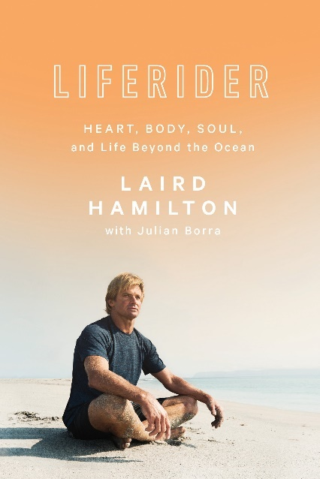
LIFERIDER
Heart, Body, Soul and Life Beyond the Ocean
Laird Hamilton

Rodale Books, Penguin Random House US
Published 28th March UK
£19.99 Hardback & eBook available

LIFERIDER explores the inner psyche and guiding philosophies of legendary surfer and international fitness icon Laird Hamilton

“LIFERIDER is Laird’s view from the lip of life; observations from where he is right now on how we might better manage the turbulence of life—the biggest wave we’ll ever ride—by reaching back into the brilliant creature we are, instead of always reaching up to the being we aspire to be.” —From the introduction by Julian Borra

In this follow-up to his New York Times bestselling book Force of Nature, surfing legend, fitness icon, and entrepreneur Laird Hamilton condenses his worldview into three simple blocks of thinking, feeling, and doing. Hamilton reveals the secrets behind his success and breaks down the principles that have motivated his extraordinary life in this prescriptive narrative that condenses his unique worldview into its three distinct elements: heart, body, and soul.
HEART explores the intrinsic motivation that drives our lives and everyday actions. BODY explores everything that affects our physical manifestations: our genetics, environment, foods, exercise, and even our breath.
SOUL seeks to help us make sense of the cat's cradle of beliefs we all carry with us, what we expect of them, and what they really mean to us.

Through a series of conversations with his co-author Julian Borra, and with insights from his wife, professional volleyball player Gabby Reece, Hamilton explores human nature, relationships, business, technology, the natural world, and more, with raw honesty and a fierce commitment to his convictions.

Rejecting the common notion behind many self-help books that enlightenment is something to strive for, Hamilton declares that we must instead look within—that all the tools we need to reach our goals already exist inside us. LIFERIDER is a lesson in empowered living, straight from the mind of a man who has built an extraordinary life by breaking down barriers and defying expectations.

LAIRD HAMILTON is an American athlete, surfer, author, inventor, stuntman, model, producer, TV host, fitness and nutrition expert, husband, father, and adrenaline junkie. He is one of today’s best-known big-wave surfers. In addition to riding many of the biggest waves on the planet, Hamilton is known as the world-renowned innovator and guiding genius of crossover board sports, including tow-in surfing, stand-up paddle boarding, and hydrofoil boarding. He lives in Malibu, California.

JULIAN BORRA has worked for more than thirty years as a creative writer in the media and communications industry at Saatchi & Saatchi, Leo Burnett, and at the consulting firm he founded, Thin Air Factory.

"When Laird Hamilton surfs, you must watch. When he speaks, I listen. And when he writes a book I'm damn sure gonna read it. Twice." - Eddie Vedder
"Laird is a hero, if you want him to be. That's up to your perception. He challenges himself, and he challenges those around him. I challenge him. He challenges me. We want the colour that life has to offer, and it seems that the deeper you puncture into life, the more vibrant the colours get."
- Josh Brolin
"Laird Hamilton is a true individualist unafraid to carve his own path. These thoughtful mediations offer a unique window - illuminating and inspiring - into one of America's great innovators."
- Rory Kennedy

Laird Hamilton is available for interview
Extracts are available

All UK publicity enquiries and review copy requests to Becke Parker:
email becke@bparkerpr.co.uk / tel 07810 480924

