Published by Penguin 21st February
Paperback original | 9780241977347 | £7.99

DAY OF THE ACCIDENT
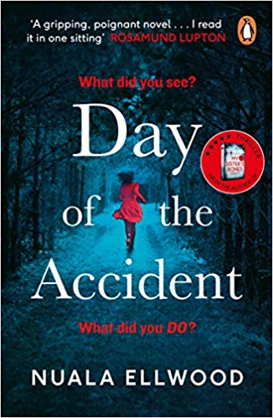
by Nuala Ellwood

A haunting new thriller by the author of My Sister’s Bones that asks the question: how far would you go to prove you didn't kill your daughter?

Sixty seconds after she wakes from a coma, Maggie's world is torn apart.
The police tell her that her daughter Elspeth is dead. That she drowned when the car Maggie had been driving plunged into the river. Maggie remembers nothing.
When Maggie begs to see her husband, Sean, the police tell her that he has disappeared. He was last seen on the day of their daughter's funeral.
What really happened that day at the river?
Where is Maggie's husband?
Nuala Ellwood was chosen as one of the Observer's 'New Faces of Fiction 2017' for her first thriller, the bestselling My Sister's Bones. Nuala teaches Creative Writing at York St John University, and lives in York with her son.

'Gripping, poignant ... I read it in one sitting' ROSAMUND LUPTON
'Brilliantly compulsive and with one hell of a twist!' CLAIRE DOUGLAS
'Makes you question everything you thought you knew' EMMA KAVANAGH

For further information, interview requests and to commission an article by Nuala Ellwood
please contact:
Becke Parker: becke@bparkerpr.co.uk / 07810 480924

PRAISE FOR MY SISTER’S BONES:

'For lovers of The Girl on the Train ...a tense story with multiple twists and turns' Prima
'A gripping rollercoaster ride of a thriller' Christobel Kent, author of The Loving Husband
'Compelling ... Brimful of tension, twists and darkness, this one grabbed me on the first page and didn't let go' Woman and Home
'Twists and turns until the last page' Tammy Cohen
'A stunning book. Compelling, unsettling and powerful this is a book that will stay with me for a long time.' C. L. Taylor
'Nuala Ellwood has created a tale that is gripping, engrossing and surprising at every turn. I loved it' Rowan Coleman
'Couldn't put the lights out until I'd finished it! Gripping, emotional and very well-written' Emma Curtis, author of One Little Mistake
'An accomplished and page-turning thriller. It twists and turns in so many directions it's impossible to guess where it's going next' Nicholas Searle, author of The Good Liar
'Loved I Let You Go and Behind Closed Doors? My Sister's Bones is guaranteed to be this year's most twisty and twisted read - you'll never see what's coming!' Ava Marsh, author of Untouchable
'Ellwood's protagonist Kate is a female hero in the best sense, flawed but brave' Helen Callaghan, author of Dear Amy
'My Sister's Bones is a tense, atmospheric, deliciously dark story' Amanda Jennings, author of In Her Wake
'A twisty psychological thriller. I raced through it in one sitting!' Lucy Atkins, author of The Other Child
'This book is amazing - harrowing and compelling' Luana Lewis

'***** Wow...creeps slowly up your spine, grips you round the throat and doesn't let you go! ' Amazon reviewer

For further information, interview requests and to commission an article by Nuala Ellwood
please contact:
Becke Parker: becke@bparkerpr.co.uk / 07810 480924

