PRESS RELEASE

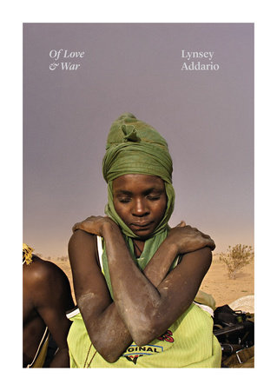
Of Love & War

Lynsey Addario

Penguin General
Published 15th November UK
£33.99 Hardback

‘This astonishing selection of photos from photojournalist Addario strongly demonstrates her conviction that by risking her life to cover gross injustices she can create visual and visceral proof of human rights violations. Addario’s two decades of documenting wrongs begins with her work on life under the Taliban in Afghanistan and Pakistan. Photos of children at play in cemeteries, a crowded room in a secret school for girls near Kabul, and a prisoner chained to the wall at an underground prison are interspersed with personal letters from Addario to her family and loved ones, her own field notes, and contact sheets. Later sections feature images of war-torn Iraq and Libya, groups of refugees on the move, and conflict in Congo and South Sudan. There’s a powerful series from the maternity ward at Magburaka Government Hospital in Sierra Leone, featuring a woman giving birth on a blood-soaked floor and a mother spoon-feeding her adult daughter, who was in a coma after having her first child. Addario’s photographs are stunning, and this book, which she dedicates to the “brave and resilient” women and men she’s documented, provides unique insight into the vital work of photojournalists.’ Publishers Weekly
Lynsey Addario has captured audiences with her disarming and compelling photographs and her uncanny ability to personalise even the most remote corners of our world. In OF LOVE AND WAR, the Pulitzer Prize-winning photojournalist returns with a stunning collection of more than two hundred of her photographs from across the Middle East, South Asia, and Africa from the last twenty years. In her distinctively dramatic style, Addario documents families living in Afghanistan under the Taliban; the stark truths of sub-Saharan Africa; the daily reality of women in the Middle East; U.S. military units on the front lines in Iraq and Afghanistan; the faces and bodies of the refugee crisis; and much more.

Through Addario’s eyes we bear witness to the human cost of war in gripping, full-colour photographs and in the form of field notes, personal letters and emails Addario has written over the years. The book also features revelatory essays from esteemed writers such as Dexter Filkins, Aryn Baker, and Lydia Polgreen, and public figures such as Christy Turlington. OF LOVE & WAR is a compelling statement about the world, and all its inescapable chaos and conflict, from one of the most brilliant and influential journalists working today in any medium.

I hope that what I have chosen for this book conveys those things that, for all those years, remained consistent in my work and in my life: love, passion, a sensitivity to injustice, a desire to provide evidence, a will to inform policy makers, and a commitment to doing justice to the stories of people who—for reasons I sometimes cannot fathom—opened their doors and hearts to me.
It is for them that I returned and will return again.
—Lynsey Addario in OF LOVE & WAR

About the Author
Lynsey Addario is an American photojournalist whose work appears regularly in The New York Times, National Geographic, and Time Magazine. She has covered conflicts in Afghanistan, Iraq, Lebanon, Darfur, and the Congo, and has received numerous awards, including the MacArthur Genius Grant and the Pulitzer Prize in International Reporting.

Lynsey Addario is available for interview
Images are available
Photographic features and extracts can be discussed
– contact Becke Parker to register interest

All UK publicity enquiries and review copy requests to Becke Parker:
email becke@bparkerpr.co.uk / tel 07810 480924

