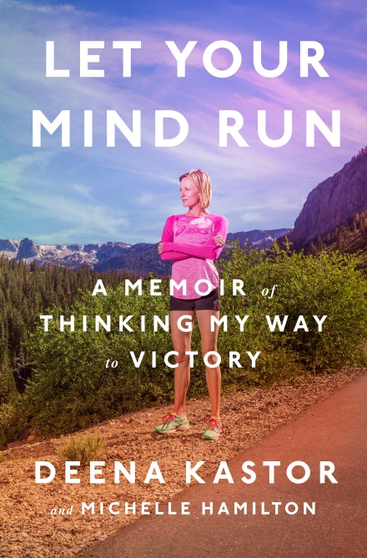
LET YOUR MIND RUN
A memoir of thinking my way to victory
DEENA KASTOR
and Michelle Hamilton

UK release 17th May
£18.99 hardback / £10.99 ebook

From an Olympic medallist and America’s fastest female marathoner, an inspirational memoir on how harnessing the power of our thoughts can unlock hidden potential and success

DEENA KASTOR was a star youth runner with tremendous promise, yet her career almost ended after college, when her competitive method – run as hard as possible, for fear of losing – fostered a frustration and negativity and brought her to the brink of burnout. On the verge of quitting, she took a chance and moved to the high altitudes of Colorado to train under legendary coach Joe Vigil. There she encountered the idea that would transform her running career: the notion that changing her thinking – shaping her mind to be more encouraging, kind, resilient – could make her faster than she’s ever imagined possible. Building a mind so strong would take years of effort and discipline, but it would propel Kastor to the pinnacle of running – to American records in every distance from the 5K to the marathon – and to the accomplishment of earning America’s first Olympic medal in the marathon in twenty years.

Blending memoir and running insights, LET YOUR MIND RUN is an intimate look inside the mind of an elite athlete, a remarkable story of achievement, and an insightful primer on how the small steps of cultivating positivity can give anyone a competitive edge.

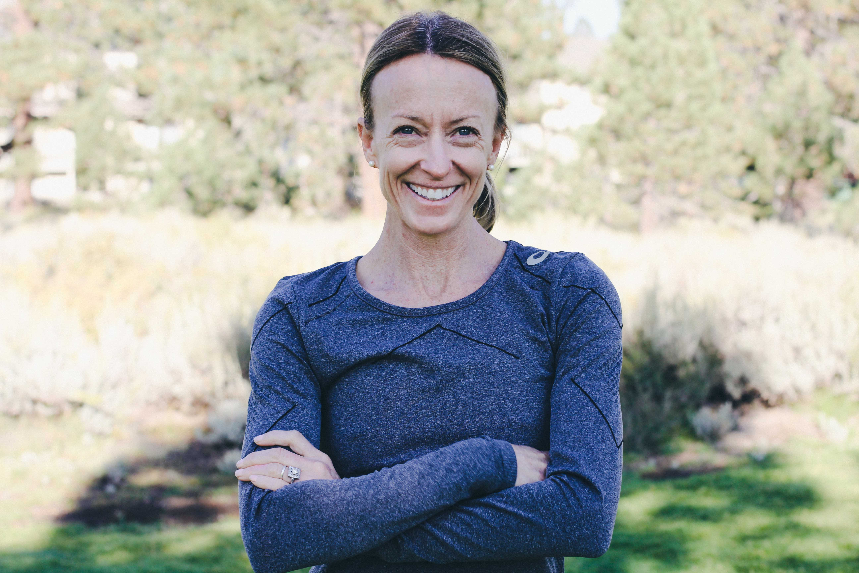
DEENA KASTOR is an Olympic medallist and the American record holder in the marathon – the first American woman to run under
2:20 in the marathon. She lives in Mammoth Lakes, California.
MICHELLE HAMILTON is a health and fitness journalist.
Her work has appeared in Runner’s World, Bicycling, Women’s Health
and other publications.
Deena Kastor is available for interview
All UK publicity enquiries and review copy requests to Becke Parker:
email becke@bparkerpr.co.uk / tel 07810 480924

