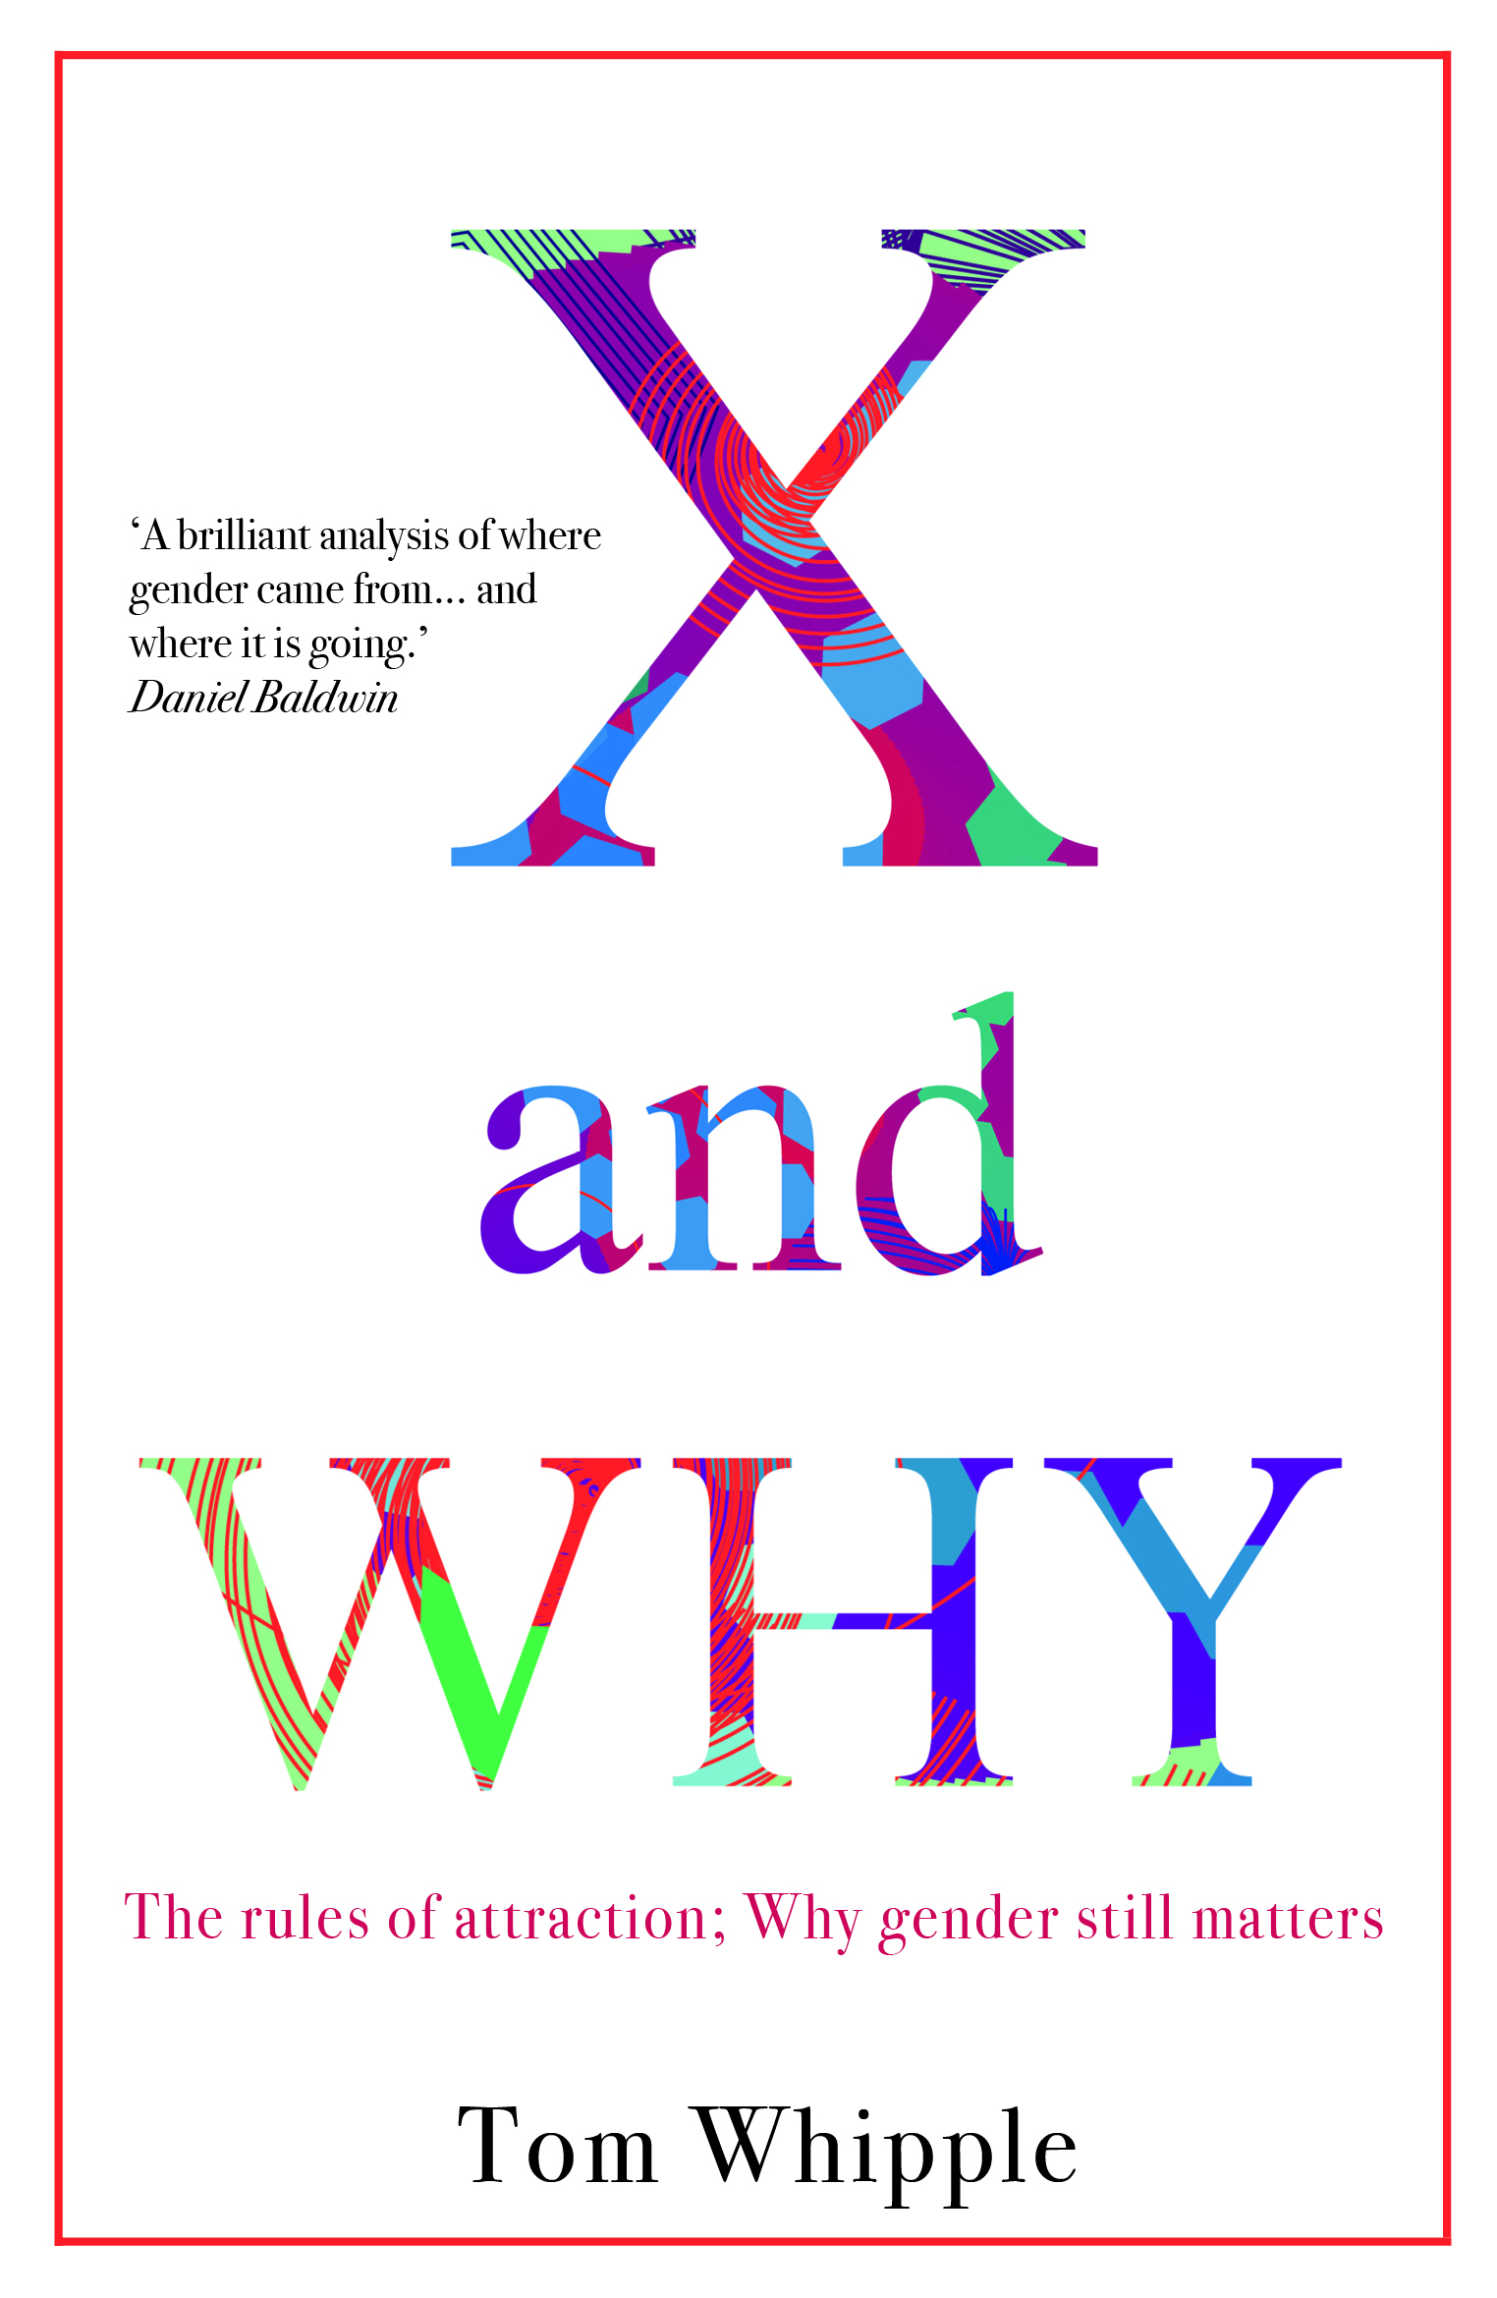

X and WHY
The rules of attraction: Why gender still matters
Tom Whipple
PUBLISHED BY SHORT BOOKS 5TH APRIL
PAPERBACK & E-BOOK £9.99

Tom Whipple, science editor of The Times, draws on the latest science to look at key questions about the differences between the sexes, and unpack the central psychology of our relationships.

Were we ever designed to be a monogamous species?

Is it true that all women are bisexual?

Is testosterone to blame for making men monsters?

This is a book about the place where biology meets behaviour – how sex drives us, and explains many of the key choices we make in life.

In this timely, but more nuanced, reboot of the seminal bestseller Men Are From Mars, Women Are from Venus, Whipple travels far and wide – from a Home Counties swingers’ party to a gay penguin sanctuary in Germany – and draws on the latest studies in behavioural science as well as fascinating explorations into anthropology to produce a surprising tale of expectations and mismatches. He shows that gender is more complicated than a simple binary, but neither is it just constructed by culture - and nowhere is this clearer than when it comes to sex and love.

If you are currently single, this book is about your place in the dating market – your successes, your failures and what they mean. If you are in a relationship, it is about why you chose the person you are with, why they chose you – and the circumstances in which either of you might put it all at risk and stray. Whatever your situation, this book might just give you an insight into the emerging science behind your sexuality.

The truth about men, women and gender identity, as Whipple demonstrates, is in the minor anomalies, rather than the accepted wisdoms – and it is these which provide the most revealing windows into the deeper mysteries of human sexuality and character.

Tom Whipple is the award-winning science editor of the London Times. This is his second book. How to Win Games and Beat People was published by Random House in the UK and HarperCollins in the US in 2015.

FOR EXTRACTS, INTERVIEW OPPORTUNITIES and REVIEW COPIES
PLEASE CONTACT:
Becke Parker / becke@bparkerpr.co.uk / 07810 480924

