Being Adam Golightly
One man’s bumpy voyage to the other side of grief

by Adam Golightly
8th Feb 2018 | MEMOIR | B Format Paperback | £8.99 | 978-1-78072-316-7
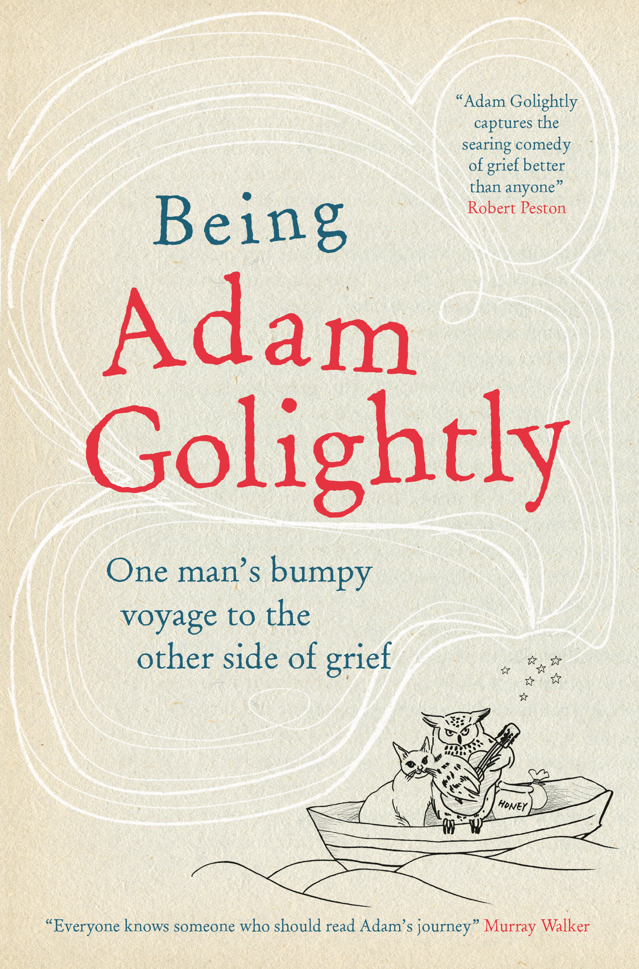
The cruel early death of his wife Helen tears up the script of Adam Golightly’s middle-class, middle-aged existence. Miserably single, outnumbered by his kids and haunted by life’s screaming fragility; he recounts his fight back against the hand of fate.
This irreverent and frank memoir follows Adam’s snakes-and-ladders journey through his grief in the year following his wife’s death; as he struggles with small town tongue wagging, the trauma of teenage bra shopping and online dating anarchy.
Adam’s is the biggest mid-life crisis anyone could face and as he starts to build a new, alternative life for himself and his children, he shows not just how to survive bereavement but how to be transformed by it.
“My writing has been cathartic and a witness to fact being more extreme, provocative and, frankly, funnier than fiction. I have learned too much about grief, but have discovered even more about myself … I can offer some sharp-elbowed nudges to help others who are grieving or who simply need to deal with change, welcome or not.
I’d like my sharing to have helped those who have experienced loss or provoked those lucky bleeders who haven’t lost anyone into thinking differently about the gap between what they want for the rest of their lives and how they are living it now.”
Practical and candid, this is much more than a ‘coping with grief’ narrative. Being Adam Golightly is an uplifting story of life-changing events and survival, told with humour and grit.
Adam Golightly (pseudonym) lives in Hertfordshire and is a recently widowed father of two. A former account planner in a big advertising firm, he wrote the weekly column ‘Widower of the Parish’ in the Guardian about adjusting to life as a single father.
FOR PUBLICITY ENQUIRIES PLEASE CONTACT:
Katherine Stroud | kstroupr@gmail.com / 07780 112964
Becke Parker | becke@bparkerpr.co.uk / 07810 480924

