HOME
ECONOMICS
How to eat like a king
on a budget

Jane Ashley

Paperback £14.99
Published by Short Books
10 January 2018 for Feb/Mar issues

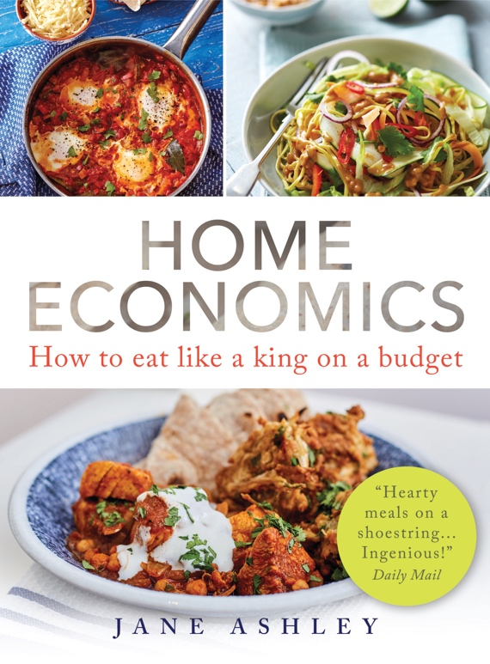

‘I started this journey into low cost eating to find out how difficult it would be to only have £1 a day to spend on all of your food. This figure of a £1 a day was set by the charity ‘Live Below the Line’ to challenge individuals to exist on for 5 days to raise awareness of people living in poverty around the world. I decided to give it a go, after my friend who helps out at our local food bank told me about people living on very little money and trying to feed their families. This could be for a variety of reasons, and everyone’s story is different. I decided with my family to join our one pounds together and try to devise a shopping list that would feed us with a varied and healthy diet, trying to include our 5 a day of fruit and vegetables.’ Jane Ashley writing on her Eat Not Spend blog

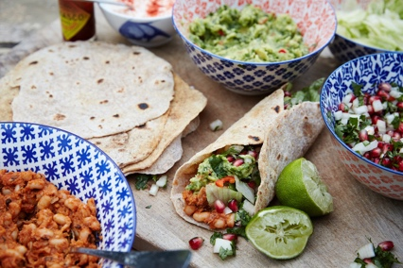

Jane Ashley is the real deal – a busy working mum who loves good food whilst striving to balance nutrition and cost. Speaking to a friend who volunteers at a food bank a few years ago, and learning about the figure of £1 set by the charity ‘Live Below the Line’, Jane pooled together her family’s pounds and set herself the task of feeding them for £3 a day. Jane decided to write about the challenge and set up her Eat Not Spend blog to ensure that she kept motivated. Now, two years on, the very best of her tried-and-tested recipes and comprehensive menu plans are published together with fully-costed shopping lists.

As more and more people found out about Jane’s blog, the requests for alternative menus flooded in. She tried various different eating plans including vegetarian weeks, vegan plans and gluten-free menus. From fried bean tacos to Thai curries, Jane’s thrifty meals are easily adapted whether cooking for one or feeding multiple mouths.

‘None of the recipes should be too complicated, they just take a bit of effort. I myself couldn’t cook until a few years ago so I have tried to make them as simple as I can. I also work full time so I try to do as much prep work for the week ahead at the weekends as possible to save time midweek.’

Budgeting for £35 per week for a family of four, Home Economics gives money-saving tips to show how everyone can feed their family on a varied and healthy diet without breaking the bank.
Jane Ashley is a graphic designer who lives with her husband and daughter in London.

FOR RECIPE EXTRACTS and FURTHER INFORMATION PLEASE CONTACT:
Katherine Stroud: kstroudpr@gmail.com / 07780 112964
Becke Parker: becke@bparkerpr.co.uk / 07810 480924
www.prcollective.co.uk

