PRESS RELEASE
GIRLING UP
How to be Strong, Smart and Spectacular
Mayim Bialik
UK release 29th June
£13.99 hardback / £9.99 ebook

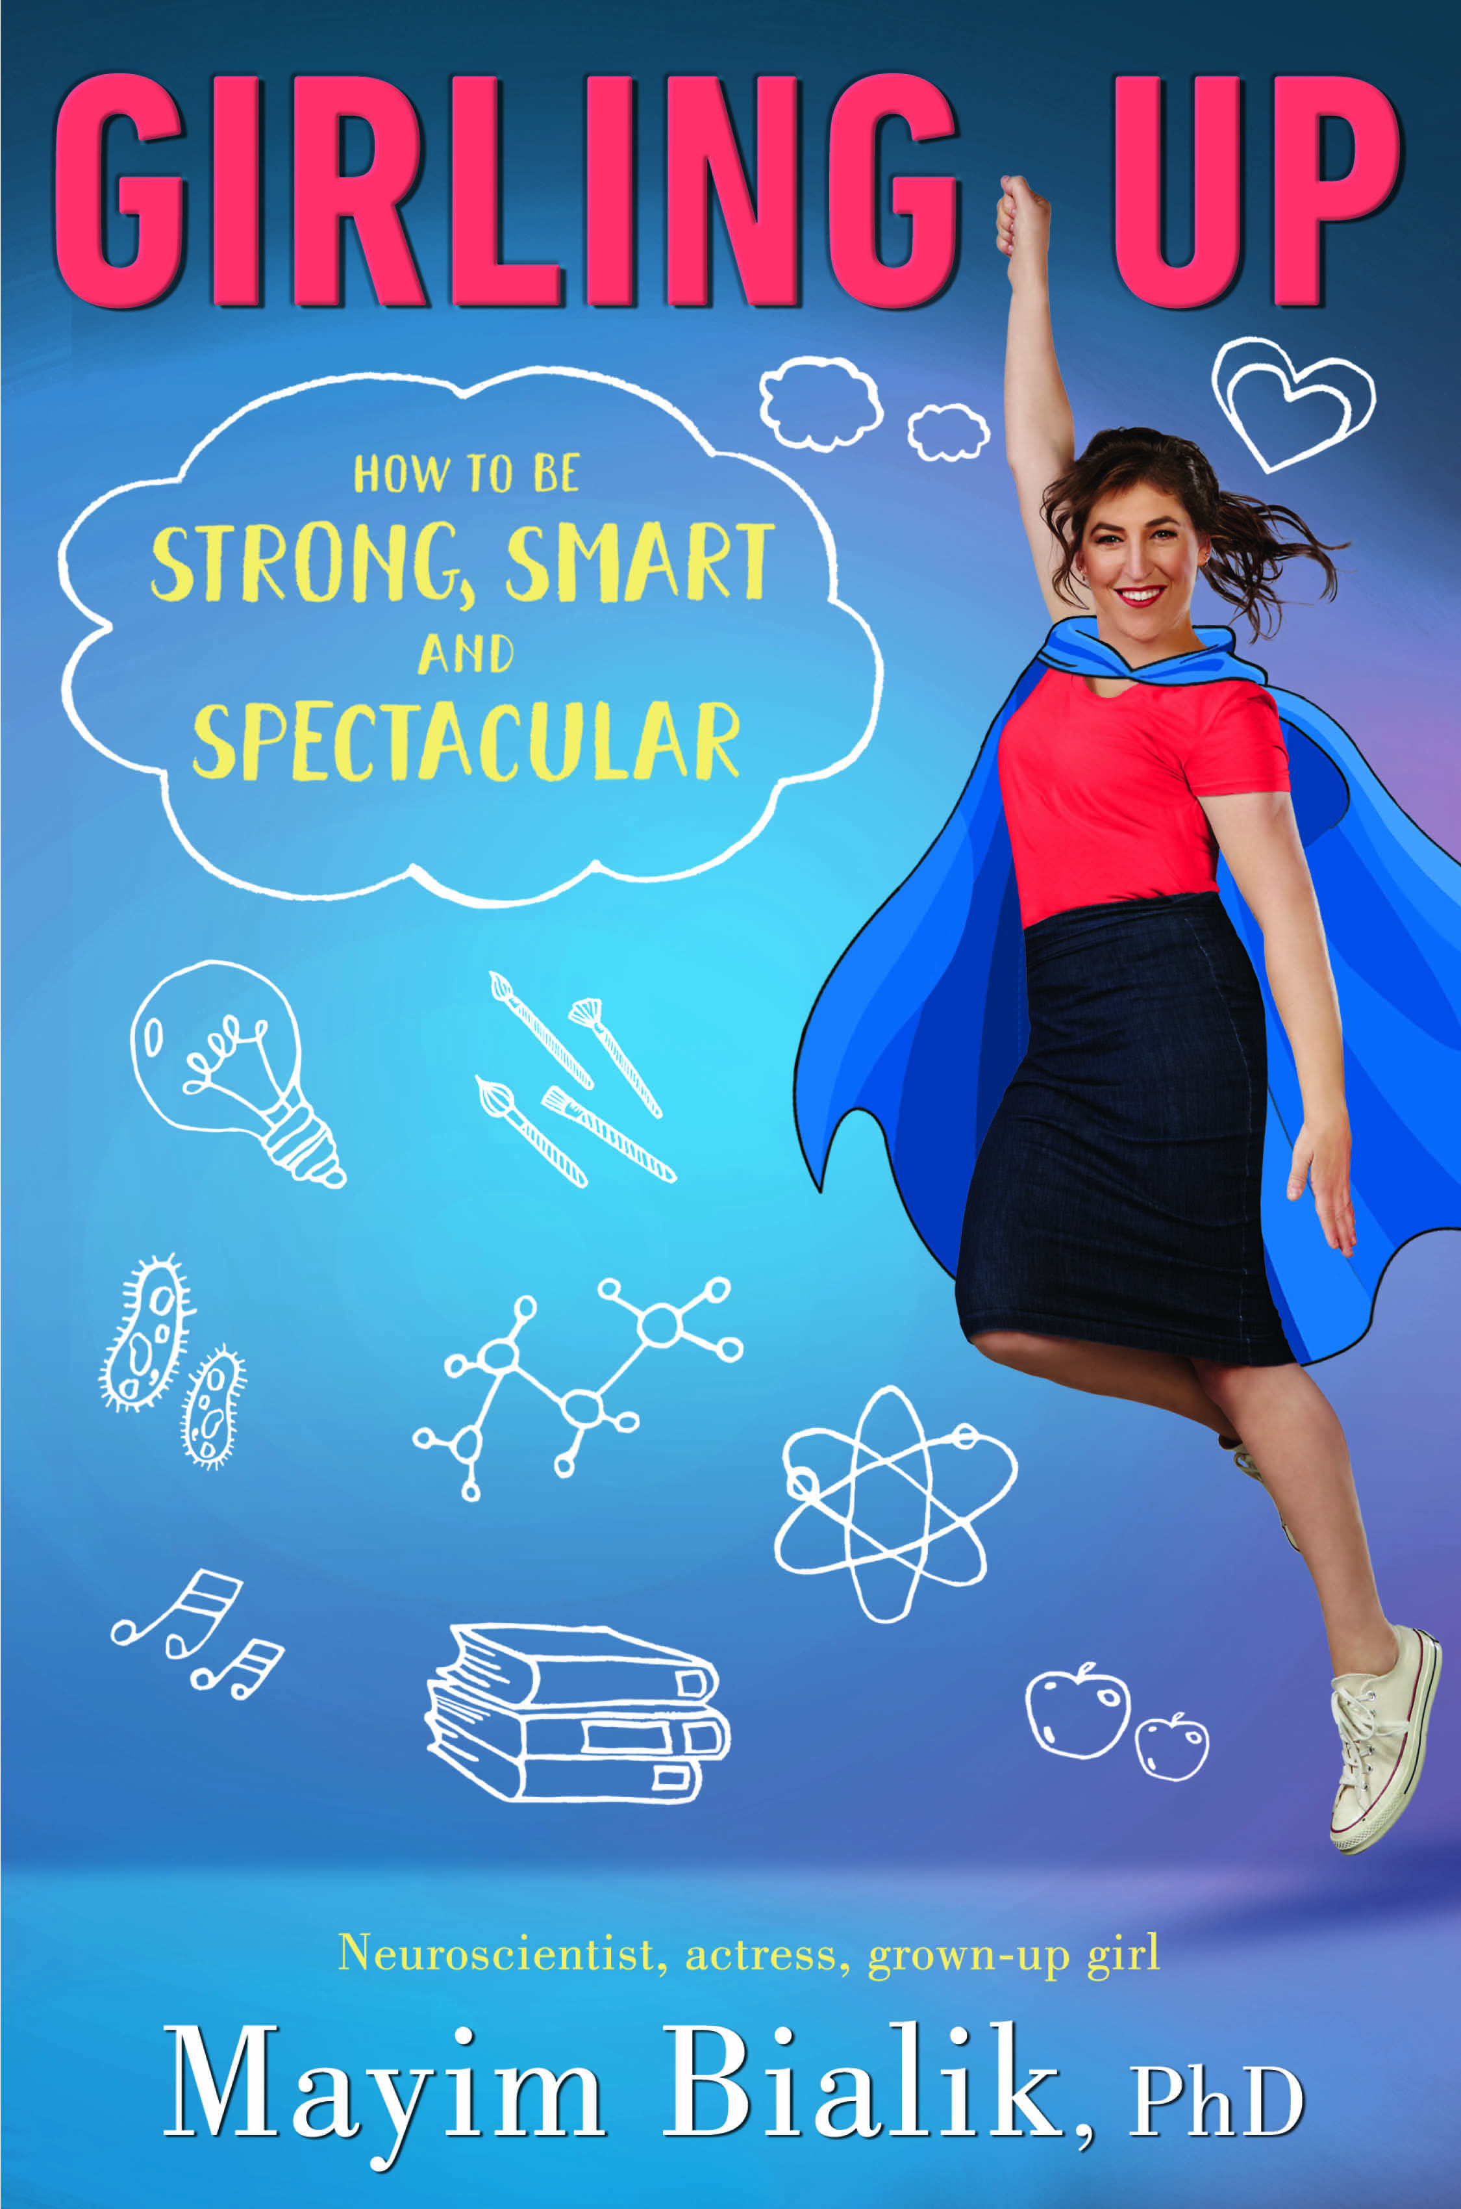

The Big Bang Theory star explores the science of being a girl

Mayim Bialik, actress, writer, neuroscientist, and founder of GrokNation.com, addresses what it means to grow from a girl to a woman biologically, psychologically, and sociologically in her new book, GIRLING UP: How to Be Strong, Smart and Spectacular. Pulling from her own experiences as an actress, scientist, and writer, Mayim discusses navigating everything from first kisses and first periods to rocky friendships, family responsibilities, gender questions, body image issues, and figuring out one's passion and place in the world.

“As a scientist who is a public person, it is incredibly gratifying to be able to combine my scientific background with my public face in order to bring Girling Up to young female readers,” says Mayim Bialik. “I've been asked to write books which have attempted to harness my public persona, but none have allowed me to utilize my scientific and neuropsychological perspective on the amazing and complex process of growing up as a female in this culture. I hope that my experience, my perspective, and my knowledge base will provide insight into all of the amazing things there are about being female and inspiration to become a unique strong, smart and spectacular female!”

Mayim Bialik is best known as Amy Farrah Fowler on America’s top comedy, The Big Bang Theory, a role for which she has received four Emmy nominations and a Critics’ Choice Award. She also starred in the early-1990s sitcom Blossom. Mayim earned a BS from UCLA in Neuroscience and Hebrew and Jewish studies, and went on to earn a PhD from UCLA in Neuroscience. She is the author of Beyond the Sling and Mayim’s Vegan Table.

Mayim founded GrokNation.com in 2015 as a platform for sharing her writing on everything from religious observance to women’s issues to politics to maintaining modesty in Hollywood. Mayim lives in Los Angeles with her smart, strong, spectacular sons.

Visit Mayim at groknation.com & youtube.com/mayimbialik
Twitter and Instagram @MissMayim

GIRLING UP How to be Strong, Smart and Spectacular
Philomel Books £13.99 hardback / £9.99 ebook

Mayim Bialik is available for interview
All UK publicity enquiries and review copy requests to Becke Parker:
email becke@bparkerpr.co.uk / tel 07810 480924

