MEDIA CONTACT:
Becke Parker
07810 480924
becke@bparkerpr.co.uk

DEVIL’S BARGAIN
Steve Bannon, Donald Trump,
and the Storming of the Presidency

JOSHUA GREEN

Under strict embargo
Published 18th July 2017
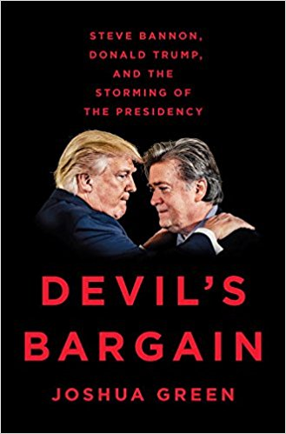

From the reporter who was there at the very beginning comes the revealing inside story of the partnership between Steve Bannon and Donald Trump—the key to understanding the rise of the
alt-right, the fall of Hillary Clinton, and the hidden forces that drove the greatest upset in American political history.

DEVIL’S BARGAIN: Steve Bannon, Donald Trump, and the Storming of the Presidency (Penguin Press: publication date July 18, 2017) by Joshua Green is based on hundreds of interviews conducted over six years. Green spins the master narrative of the 2016 campaign from its origins in the far fringes of right-wing politics and reality television to its culmination inside Trump’s penthouse on election night.

The shocking elevation of Bannon to head Trump’s flagging presidential campaign on August 17, 2016, hit political Washington like a thunderclap and seemed to signal the meltdown of the Republican Party. Bannon was a bomb-throwing pugilist who’d never run a campaign and was despised by Democrats and Republicans alike.

Yet Bannon’s hard-edged ethno-nationalism and his elaborate, years-long plot to destroy Hillary Clinton paved the way for Trump’s unlikely victory. Trump became the avatar of a dark but powerful worldview that dominated the airwaves and spoke to voters whom others couldn’t see. Trump’s campaign was the final phase of a populist insurgency that had been building up in America for years, and Bannon, its inscrutable mastermind, believed it was the culmination of a hard-right global uprising that would change the world.

During the course of his campaign reporting for DEVIL’S BARGAIN, Josh Green had access to many of the key players, from Trump himself, to long hours with Steve Bannon, Jeff Sessions, Stephen Miller, Reince Priebus, Sean Spicer, Roger Stone, David Bossie and many more. The book is a tour-de-force telling of the remarkable confluence of circumstances that decided the election. But to understand Trump's extraordinary rise—and his recent struggles—you have to go all the way back and begin with Steve Bannon, otherwise it simply doesn't make sense.
Inside the DEVIL’S BARGAIN:
- How Steve Bannon’s years in a right-wing Roman Catholic military academy shaped his apocalyptic world view
- How Bannon’s early experience in the Navy, especially in the Gulf during the Iran hostage conflict, shaped his politics and gave rise to his Islamophobia
- How and when Bannon soured on Democratic politics
- How Bannon’s early years at Goldman Sachs influenced his view of Wall Street
- How Bannon discovered the origins of the alt-right in the video-gaming world and brought it first to Breitbart News, and then to Trump's presidential campaign
- How Bannon’s relationship with the Mercer family was formed and how he exploited it
- The hidden story of how Trump was once hugely popular with minorities, but torched that support to win the GOP nomination
- How Rebekah Mercer convinced Trump to hire Bannon and Kellyanne Conway
- How Trump exploded at Paul Manafort, and had Jared Kushner later fire him
- The pitched battle between Roger Ailes and Steve Bannon over Megyn Kelly and Fox News' coverage of the Trump campaign
- How Bannon recruited Jeff Sessions to be the first senator to back Trump
- The two “essentials” Bannon gave Trump that led to his success
- Why Bannon succeeded with Trump where others failed
- How Bannon and Trump recognized Hillary's weaknesses and exploited them
- What really happened inside Trump Tower on Election Night

The Author:
Joshua Green is a Senior National Correspondent for Bloomberg Businessweek, focusing on political coverage for the magazine and Bloomberg News. Previously, Green was senior editor of The Atlantic, a weekly political columnist for the Boston Globe, and an editor at The Washington Monthly. He has also written for The New Yorker, Esquire, Rolling Stone, and other publications.

Devil's Bargain: Steve Bannon, Donald Trump, and the Storming of the Presidency
Joshua Green | ISBN 9780735225022 | HB | Published 18 / 7/ 17 | £16.99 Penguin Press

To schedule an interview or for more information, please contact:
Becke Parker / 07810 480924 / email: becke@bparkerpr.co.uk

