AMBRIDGE’S ORIGINAL SHOCKING STORYLINE…
THE ARCHERS:
The Death of Grace Archer
BBC RADIO 4 FULL-CAST DRAMATISATION
Starring Ysanne Churchman, Norman Painting & Simon Russell Beale
27th October · £16.50 · 3 CDS or available as a download · 3 hours duration

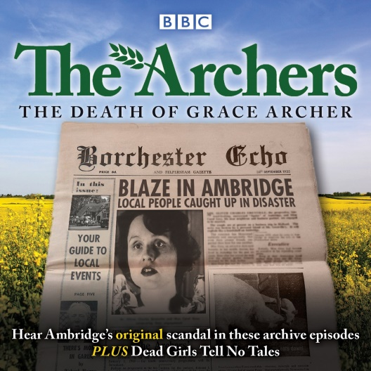
The legendary demise of Phil Archer’s first wife is recalled in these archive editions of the much-loved BBC radio serial, plus a unique behind-the-scenes drama about Grace’s death.
The Archers is the longest-running radio drama in the world, and in 1955 the death of Grace Archer became one of the most notorious – and controversial – events in the history of the show. Over 20 million people tuned in to hear the shocking storyline, and the BBC switchboard was jammed with thousands of calls from distraught listeners.

This Archers retrospective includes the omnibus edition from September 1955, featuring the fateful night of Grace's demise, and two editions of Vintage Archers from 1986 and 1987 in which the residents of Ambridge – including Jill, Walter, Tom, Shula and Christine – gather at Christmas and remember events of the past.

Finally, in the 2015 radio play Dead Girls Tell No Tales, the real-life circumstances of Grace's departure from the serial are dramatised by long-term Archers writer Joanna Toye. With a star cast including Eleanor Tomlinson (Demelza in Poldark), Simon Russell Beale, Ysanne Churchman, Jon Culshaw, Pam Ferris and Miles Jupp, it delves deep into The Archers' archives to reveal the truth about why Grace had to die.

The Archers was first broadcast on BBC radio in 1951, and it continues to this day, with a new episode broadcast daily on BBC Radio 4 (excepting Saturdays) plus an omnibus edition on Sundays. The story centres around the inhabitants of the village of Ambridge, including the Archers, the Grundys, the Aldridges and the Carters. In 1965 the death of Grace Archer caused a national outcry, and the serial continues to attract press attention regularly.
JOANNA TOYE has been writing for the programme since 1984, and in 2015 she wrote the spin-off radio drama Dead Girls Tell No Tales, about the killing off of Grace Archer.

www.penguin.co.uk/penguin-books/audiobooks www.facebook.com/BBCTheArchers

FOR REVIEW COPIES AND MORE INFORMATION PLEASE CONTACT: Sue Amaradivakara, PR Collective
07786 626492 / 020 7635 3877 / sue@prcollective.co.uk / @SueA1001

