FOR IMMEDIATE RELEASE

RECLAIMING CONVERSATION
The Power of Talk in a Digital Age
By Sherry Turkle

Penguin Press US
Paperback Original £12.99
UK Publication date 15th October

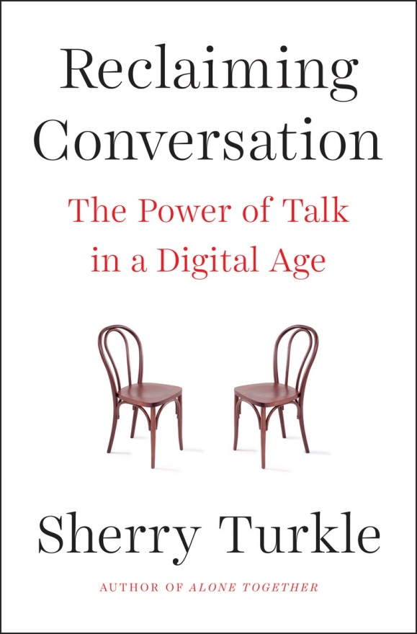

Praise for Reclaiming Conversation:

“Turkle examines every aspect of conversation – with the self in solitude, with family and friends, with teachers and romantic partners, with colleagues and clients, with the larger polity – and reports on the electronic erosion of each … But, unlike in Alone Together, where Turkle was content to diagnose, the tone of Reclaiming Conversation is therapeutic and hortatory.

Reclaiming Conversation is best appreciated as a sophisticated self-help book. It makes a compelling case that children develop better, students learn better, and employees perform better when their monitors set good examples and carve our spaces for face-to-face interactions.

The appeal of Reclaiming Conversation lies in its evocation of a time, not so long ago, when conversation and privacy and nuanced debate weren’t boutique luxuries.”
Jonathan Franzen

Sherry Turkle – renowned media scholar, tenured professor at MIT, and author of the New York Times bestseller Alone Together – has spent the last thirty years studying the psychology of our relationship with technology. Our technological universe has led to a flight from conversation where we sacrifice face-to-face exchanges for mere connection. Technology has many benefits, of course, but there is a critical consequence. Based on years of research, Turkle argues in RECLAIMING CONVERSATION: The Power of Talk in a Digital Age that our relationship with technology endangers our capacity for empathy. When conversation is under assault, so too are our families, our friendships, our intimate relationships, our classrooms, our boardrooms, and our very sense of our selves.

Today, we often find ways around conversation, tempted by the safety of a text or an email in which we don’t have to look, listen, or reveal ourselves. At home children compete with phones for their parents’ attention or are sated with a screen to keep quiet. A group of friends work to keep conversations going when only a few people look up from their phones. At work, we retreat to our screens although research shows that it is conversation at the water cooler that increases not only productivity but commitment to the job.

When we engage in conversations in which we are fully present to each other we learn to listen, develop compassion, experience the joy of being heard and understood. Most importantly, the conversations we have with others teach us about self-reflection, helping unleash creativity and productivity.

Turkle puts forth that conversation begins in solitude, by stepping away from technology, and reckoning with who we are. This necessary act is endangered: these days, always connected, we see loneliness as a problem that technology should solve. Afraid of being alone, we rely on devices, social media, and other people to give us a sense of ourselves. As a result our capacity for empathy and relationship suffers.
But there is good news: we are resilient. Conversation cures. It begins with mentorship that stresses the value of conversation. In her years of fieldwork, Turkle has found many action steps that she details here. When parents designate “sacred spaces” that are free of distracting technology and in which family conversations can flourish, children engage and learn to register and acknowledge other people’s feelings, and can even lower instances of bullying. When educators and business leaders discourage constant multitasking, which studies have demonstrated leads to lower productivity, students and workers thrive. When citizens move from online “activism” to real-world action, change actually happens.
Based on research and extensive interviews in homes, schools, and the workplace, Turkle argues that we have come to a better understanding of where our technology can and cannot take us and that the time is right to reclaim conversation. The virtues of person-to-person conversation are timeless, and our most basic technology, talk, responds to our modern challenges. We have everything we need to start. We have each other.

ABOUT THE AUTHOR:
Sherry Turkle has spent the last 30 years studying the psychology of people’s relationships with technology. She is the Abby Rockefeller Mauzé Professor of the Social Studies of Science and Technology at MIT. A licensed clinical psychologist, she is the founder and director of the MIT Initiative on Technology and Self. Turkle is the author five books and three edited collections, including a trilogy of three landmark studies on our relationship with digital culture: The Second Self, Life on the Screen and most recently, Alone Together. A recipient of a Guggenheim and Rockefeller Humanities Fellowship, she is a featured media commentator. She is a recipient of a Harvard Centennial Medal and a Fellow of the American Academy of Arts and Sciences.

“In a time in which the ways we communicate and connect are constantly changing, and not always for the better, Sherry Turkle provides a much needed voice of caution and reason to help explain what the f*** is going on.” —Aziz Ansari, author of Modern Romance
"Drawing from hundreds of interviews, [Turkle] makes a convincing case that our unfettered ability to make digital connections is leading to a decline in actual conversation—between friends and between lovers, in classrooms and in places of work, even in the public sphere. In having fewer meaningful conversations each day, Turkle argues, we’re losing the skills that made them possible to begin with—the ability to focus deeply, think things through, read emotions, and empathize with others." —The American Scholar

For more information or to schedule an interview, please contact:

Becke Parker - tel 07810 480924 - email becke@bparkerpr.co.uk

