How Good is
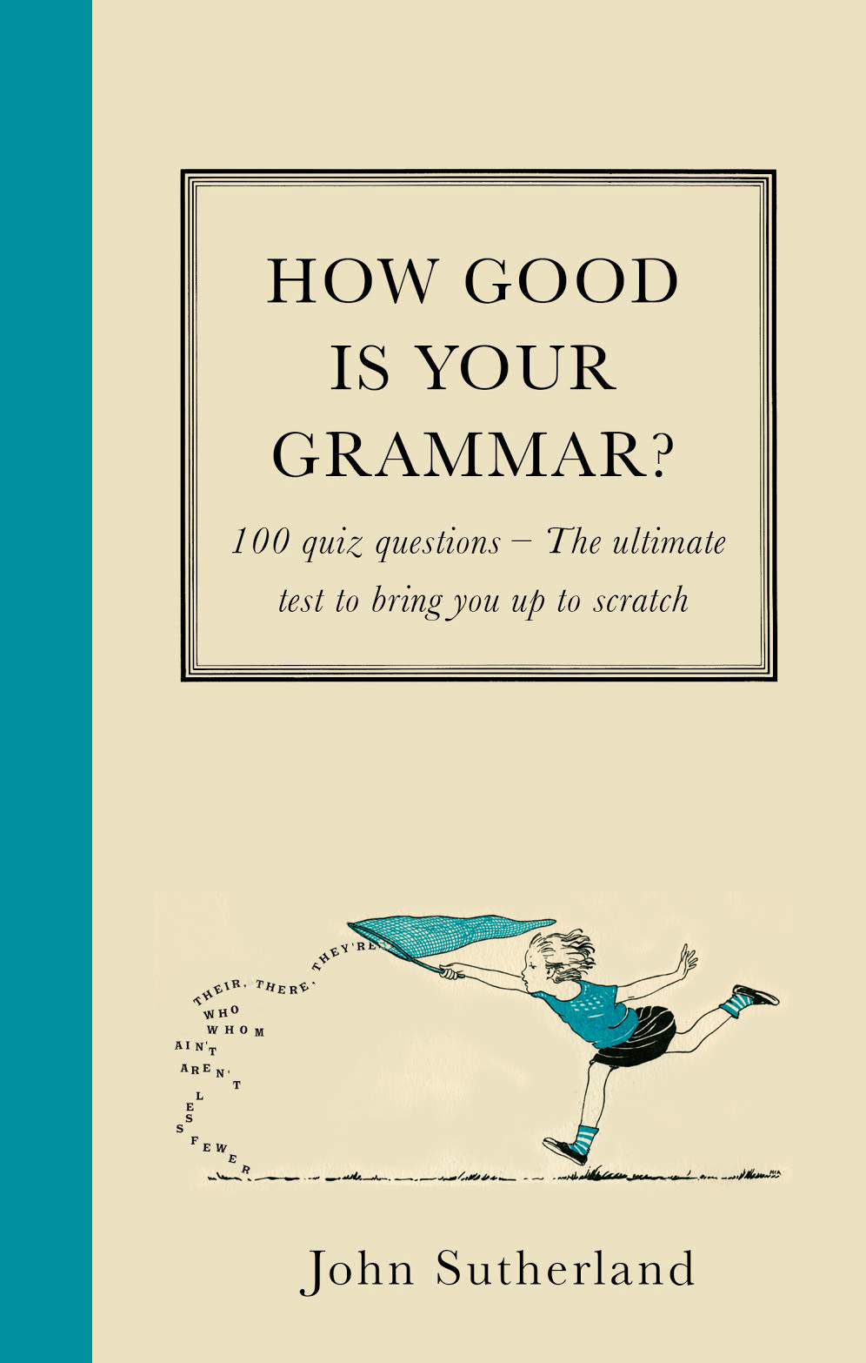
Your Grammar?

John Sutherland

Published by Short Books in Hardback & E-Book
on 15th October, £12.99

How good is your grammar? John Sutherland poses this infinitely fascinating question, and puts us all on the spot in the most illuminating and enriching way. Full of tests and quizzes, How Good is Your Grammar? is not a rule book, or ‘primer’ – although the author lays down a set of ‘Queensberry Rules’ (he is, after all, a Professor), before getting on to the interesting stuff.
How much does it matter, for example, that for purists ‘Telephone’ is ungrammatical, ‘Television’ grammatical?* How grammatically disastrous was the 42nd President’s proclamation to the world, ‘I did not have sexual relations with that woman…’** Does it matter that USS Enterprise resolves to boldly go at warp speed through the split infinitive…?
Elsewhere ‘bad’ grammar, as text-books define it, is a creative necessity: If poetry is the graveyard of grammar (think e e cummings), then popular music dances merrily on grammar’s grave (‘I feel good!’ – surely that should be ‘well’, James?), while text-speak could be either linguistic barbarism or a fascinating test-tube example of grammar’s powers of adaptation. This book offers a deliciously challenging parlour game approach to grammar. It is a quizzy, fizzy, learned book, which will entertain, amuse and instruct – wherever English is spoken (sic).
John Sutherland – Lord Northcliffe Professor Emeritus, UCL – is the author of over 30 works of scholarship and is a well-known journalist who writes regularly for the London and New York Times, the Guardian and many places else (spot the solecism).

* Television has two Greek root words, and is therefore grammatical. Telephone has a Greek and Latin root word – a grammatical no/no. For those, that is, who care about such things.
** Clinton’s ‘that woman’ allows the possibility there were other women.

FOR MORE INFORMATION PLEASE CONTACT:
Katherine Stroud: kstroudpr@gmail.com / 07780 112964

