CRAVING Esther Gerritsen
Translated from Dutch by Michele Hutchison

WORLD EDITIONS · 22nd January 2015 · £9.99 · ebook available

“Hilarious and painful at the same time” De Volkskrant

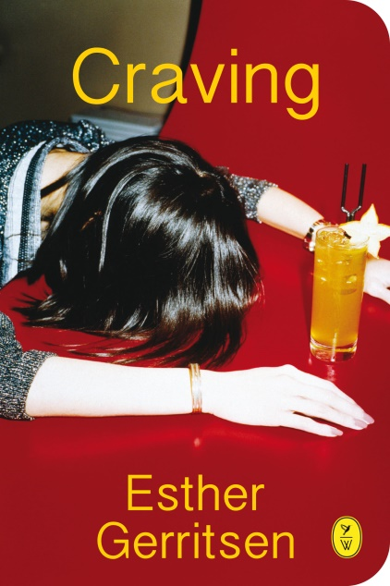
The relationship between Coco and her mother, Elisabeth, is uneasy to say the least. As a child, Coco went to live with her father when her parents separated, seeing her mother once a week. Now Coco is an adult, they meet far less frequently. Her father remarried and at family get-togethers, he and his second wife often talk about Elisabeth, speculating whether she has undiagnosed Asberger’s.

So when mother and daughter bump into each other by chance and Elisabeth casually tells Coco that she is terminally ill, it sends Coco into a tailspin of complicated emotions. With her own life in disarray, Coco decides to move in with her mother and take care of her, forcing aspects of their troubled relationship to come to the fore once again. Elizabeth tries her hardest to conform to the image of a loving mother, but struggles to deal with Coco’s increasingly erratic behaviour.

Esther Gerritsen’s whip sharp dialogue and dark humour perfectly captures our human frailties…how relationships fracture, how we talk at cross purposes and why it sometimes feels easier to skirt around the truth.

Funny, moving and memorable, Craving is a wryly observed novel about family.

“Craving is a razor-sharp psychological duet” Libris Literature Prize

ESTHER GERRITSEN is a successful Dutch playwright and writer who made her literary debut in 2000. Both her novels Superduif (‘Superdove’) and Dorst (‘Craving’) were nominated for the prestigious Libris Literature Prize. Craving sold more than 20,000 copies in the first six months upon its Dutch publication in 2012. In 2014, Esther Gerritsen was awarded the Frans Kellendonk Prize. She appears frequently in the Dutch media.

ESTHER GERRITSEN WILL BE IN THE UK ON THE 19TH AND 20TH JANUARY AND IS AVAILABLE FOR INTERVIEW
For more information please contact Sue Amaradivakara, PR Collective
07786 626492 / 020 7635 3877 / sue@prcollective.co.uk / @SueA1001

