**AN UNPRECEDENTED INSIGHT INTO THE WORLD'S MOST SECRETIVE COUNTRY**

**DEAR LEADER**

**North Korea’s senior propagandist exposes shocking truths behind the regime**

**JANG JIN-SUNG**

**Translated by SHIRLEY LEE**

**8th May 2014 / £20 Hardback, ebook available / Rider Books**

*We are told to remain silent. Everything is white: the chairs, the floor, the walls. There are no windows. Instead, there are squares of green-tinged light shining from built-in panel walls. We stand rigidly, staring in silence at a pair of closed gates. They are large and white, and decorated with gilded flowers. When the gates finally open, a guard marches through and stands to attention.*

*‘The General will now enter the room,’ he announces.*

*Everyone and everything turns to stone.*

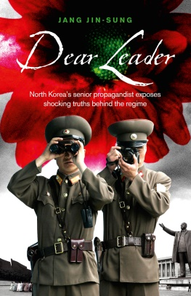***DEAR LEADER* is a devastating account of life in North Korea by a former Party insider. The importance of Mr Jang's standing in North Korea and how damaging his testimony is to the regime cannot be overstated - never before has a member of the elite described how this totalitarian state is actually run.**

Jang Jin-sung was a cadre in Section 5 (Literature), Division 19 (Poetry) of Office 101. Personally endorsed by Kim Jong-il for a triumphalist poem he'd penned glorifying the Kim dynasty and the State, he was anointed a Poet Laureate for North Korea. Enjoying a privileged position within the party, Mr Jang was bestowed with food provisions, a travel pass and, due to the nature of his work in Office 101, access to strictly censored material from South Korea.

Mr Jang’s life in Pyongyang made him ignorant of the horrific suffering of his fellow North Koreans, many of whom lived in atrocious conditions, subject to unimaginable poverty. It was not until he used his special status to travel back to his hometown that his eyes were opened. He was shocked to discover it had deteriorated into a vision of hell, his former townsfolk now starving, wretched and hopeless. Jin-sung’s experience led him to privately question the regime, and he began to confide in his best friend, fellow cadre and former classmate, Hwang Young-min, composer to the Wangjaesan Orchestra, Kim Jong-Il’s court entertainers. The young men could not have foreseen how their affluent existence would so soon be utterly shattered. When a forbidden magazine Jin-sung illegally lent to Young-min was accidentally left on public transport, the men fell foul of the regime. They would soon feel the full force of North Korea’s ruthless brutality, their terror compounded by the merciless ‘guilt by association’ decree – family members for two subsequent generations are horribly punished and often put to death for the ‘crimes’ of their relative.

A unique and highly readable account, ***DEAR LEADER*** exposes a side of North Korea which has never before been seen. It is also the heart-stopping story of an escape to freedom.

**THE AUTHOR:** Jang Jin-sung is a former court poet for North Korean leader, Kim Jong-il. Since leaving the country he has become a bestselling author and poet, and has had the attention of the worldwide media. He has been awarded the Rex Warner Literary Prize and read his poetry at London’s Cultural Olympiad in 2012. He now lives in South Korea and is Editor-in-Chief of New Focus International, an authorative website reporting on North Korea – [www.newfocusintl.com](http://www.newfocusintl.com)

**Mr JANG WILL BE IN THE UK BETWEEN 5th – 9th MAY**

**For more information please contact Sue Amaradivakara, PR COLLECTIVE**

**Tel: 020 7635 3877 / 07786 626492 /** [**sue@prcollective.co.uk**](mailto:sue@prcollective.co.uk)