**GRAVITAS**

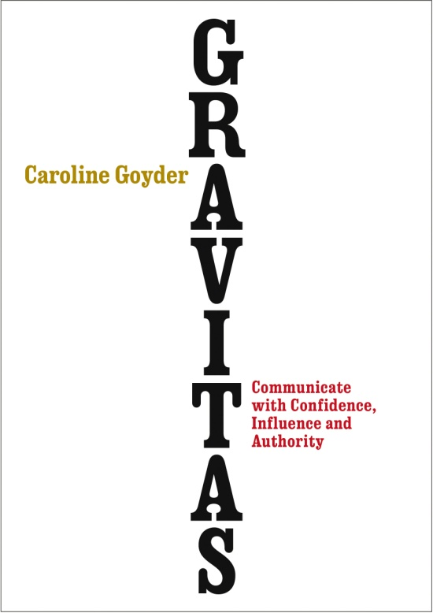**Communicate with Confidence, Influence and Authority**

**By**

**Caroline Goyder**

**Published by Vermilion | 6th March 2014 | Trade Paperback| £12.99**

Have you ever wondered why some people earn attention and respect when they speak and others don't? The secret to their success can be summed up in one word: gravitas.

In this revolutionary new book, **GRAVITAS**, leading voice coach **Caroline Goyder** reveals how to speak so others will listen. Using simple techniques to build your natural gravitas, you will learn how to express yourself clearly with passion and confidence to persuade, influence and engage listeners. By being grounded in your values and capabilities, you will gain the authority needed to make people sit up and pay attention.

Gravitas is an ancient method of communication, a skilled art form, that up until relatively recently was learnt, practised and passed on through generations. Nowadays we find ourselves communicating via digital platforms where we can speak to hundreds, thousands, sometimes millions of people, at the press of a button. Expressing yourself clearly and with confidence is more important than ever, but it is a life skill that most people aren’t taught. In a competitive world, success favours the articulate: it really does matter what you say and how you sound when you say it.

Each chapter of **GRAVITAS** guides you step-by-step through practical techniques and exercises to give you the skills for great presentations, productive meetings and persuasive pitches. You'll overcome anxiety, learn how to deal with difficult people and feel calm and in control when public speaking. **GRAVITAS** is set to become the essential guide for anyone who wants to improve their communication, their confidence and their impact. Whether it’s a job interview or a company presentation, a church elegy or wedding speech, with **GRAVITAS**, Caroline Goyder aims to restore our proficiency at conveying our ideas, message, aims and expertise, through calm, confident and lucid communication.

**GRAVITAS** will teach you to:

* KNOW YOURSELF – How to build your inner strength so you are confident, grounded and decisive
* TEACH PEOPLE HOW TO TREAT YOU - How to balance your credibility with your warmth so others respect you AND like you.
* FIND YOUR VOICE - How to speak with originality and clarity – so you have something to say worth hearing and to express it in a voice that sounds great voice
* WIN HEARTS AND MINDS - How to inspire, engage and persuade audiences
* KEEP YOUR COOL- How to stay calm, resourceful and influential when dealing with difficult people

**Caroline Goyder** is a voice, presentation and public speaking expert and mentor, and a popular speaker. Caroline has specialized for nearly a decade in helping non-acting clients to perform with poise and power in real life, whether they are delivering a speech, anchoring a TV show, impressing at interview, or chairing a board meeting. She worked for ten years as a voice coach at Central School of Speech and Drama and continues to support clients in business, politics and broadcast with the challenge of communicating with impact in the theatre of life. She is regularly asked to comment in the media on voice and communication issues. These include; BBC Breakfast News (BBC ONE), ‘The Speaker’ (BBC TWO), ‘The Voice’ (BBC FOUR), Caroline has also been featured in *The Times*, *Daily Telegraph*, *New Statesman*, *Sunday Times*, *The Guardian* and the *Daily Mail*.

**Caroline Goyder is available for interview**

For further information contact:  
Claire Scott - 020 7840 8274 / [cscott@eburypublishing.co.uk](mailto:cscott@eburypublishing.co.uk)  
Sue Amaradivakara – 07786 626492 / [1001sca@gmail.com](mailto:1001sca@gmail.com)  
**Twitter @CarolineGoyder**  
[www.gravitasmethod.com](http://www.gravitasmethod.com)

